Country – Bulgaria

1) National youth employment situation

In 2014 the youth unemployment rate was 26.1%. This was a significant increase compared to the 2008 rate of 11.9%. At the start of the economic and financial crisis in 2008 there was a stark fall in the employment prospects for young people. However there are now signs of improvement especially for young people. The most recent data shows a tendency for quicker improvements in the youth unemployment situation compared to the overall rate of unemployment. This could mean that youth unemployment is determined not only by the business cycle but also by powerful structural factors such as experience and skills. This thesis is supported by the fact that even in the growth years youth unemployment remained two to three times higher than adult unemployment and the activity and employment rates in the youth labour market were low compared to most of the other EU28 countries.
One characteristic of the Bulgarian youth labour market is the high number of youngsters who are not in employment, education or training (NEET). The country is somewhere in the middle in terms of youth unemployment rates compared to other EU countries. Unfortunately this position could be misleading because Bulgaria has the second highest NEET rate in the EU28 (21.6% in 2014 compared to the EU country average of 13%). Young Bulgarians are not just unemployed they are inactive. The big issue that Bulgaria needs to tackle is not youth joblessness but youth inactivity. Both issues need to be addressed simultaneously.

The impact of this situation can be seen in many ways e.g.:
- since 2008 the number of inactive youngsters who want to work has increased. This tendency could be explained by reductions in the disposable income of many households. In these situations more members of the household are looking for work as a way of coping with their financial problems (World Bank, 2011);
- the proportion of young people who feel ‘discouraged’ is steadily rising. This growth is closely related to the number of young people who spend long periods of time without a job;
- the growth in the number of discouraged young people who want to work is gradually increasing the number of people who are inactive and do not want to work;
- there is a gradual increase in the number of young people who take shelter from the economic recession in the education system and not included in the NEET group.

In Bulgaria the majority of NEETs have a lower educational level than average. The EU Labour Force Survey shows that 52% of NEETs in Europe have never worked. This is particularly pronounced in the case of Bulgaria where approximately 70% or more of current NEETs have no work experience. As a share of GDP, the economic loss due to the non-participation of young people in the labour market at a European level increased from 0.96% in 2007 to 1.21% in 2011. At the Member State level, the situation has deteriorated considerably in many countries such as Bulgaria where the cost of NEETs in 2011 was more than 3% of GDP.

Employment of young people
Under existing Bulgarian legislation, young people become capable of work at the age of 15 years - working at an earlier age is possible if certain protections are in place. In 2013 the youth employment rate was 21.2%. Since the start of the 2008 financial and economic crisis the youth employment rate (for those aged from 15-24) has fallen by 5%. The percentage of self-employed young people aged from 15 to 24 is 3.4% which is below the EU average. The percentage of self-employed 25-29 year olds in Bulgaria has risen to 5.7% but it is still below the EU average of 8.7%.

Skill Needs
CEDEFOP’s initiatives include skills forecasts through its Skillsnet network. Members of this network are involved in identifying the skills that are needed by employers. This is based on forecasting, employer surveys, sectoral analysis and privileged access to information. CEDEFOP uses employers’ surveys as a way to identify skill needs and skill gaps at the workplace level. They are aiming to develop a tool or instrument which can reliably identify the future needs for skills, competences, occupations and qualifications in the public and private sector. According to the studies developed by CEDEFOP in the field of skill needs and job opportunities in Bulgaria it is possible to highlight:
- that the opportunities for new jobs in all sectors are mainly due to the replacement of existing jobs. An expansion in demand for employment only exists in the business and other services sector;
- opportunities for new jobs are only in those elementary occupations where there is an increase in demand;
- up to 2025 an increase in the employment of those people with high levels of education and a fall in the employment of men and women with low and medium levels of education.
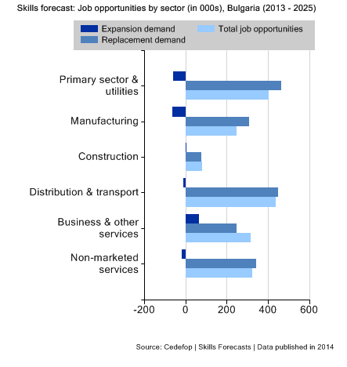
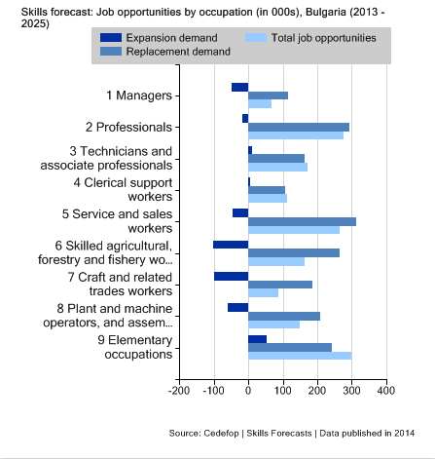

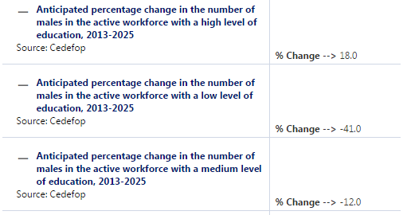
Source: EU Skills Panorama/ CEDEFOP

2) VET system in Bulgaria

The VET system includes vocational guidance, vocational training and vocational education. In this context vocational guidance offers information, advice and counselling to students and others when they choose their profession or career. Vocational training includes:
- initial vocational training and the acquisition of an initial vocational qualification in a profession or part of a profession;
- continuing vocational education to improve existing qualifications in a profession or part of a profession.
- a vocational qualification which can be acquired at one of the following four levels:
- the first level enables learners to acquire the professional competences for those occupations which include routine activities that are carried out under steady conditions;
- the second level enables learners to acquire the professional competences for those occupations that include activities of a complex nature that are carried out under changing conditions;
- the third level enables learners to acquire the professional competences for those occupations that include complex activities carried out under changing conditions, and include responsibility for the work of others;
- the fourth level enables learners to acquire the professional competences for those occupations that include broad range of complex activities carried out under changing conditions with management responsibility for the work of others and the allocation of resources.

The acquisition of vocational qualifications is regulated by Framework Programmes which are approved by the Minister of Education, Youth and Science. These Programmes determine the age; educational entry and qualification level of candidates; the content and duration of vocational education and training.

The main structural elements of the Framework Programmes are:
- a set of general provisions which include regulations, aims and purpose;
- the requirements for applicants to a training programme – the requirements differ for candidates who are over the age of 16. The requirements for applicants include a minimum age requirement, medical conditions, and an entry level of education. The programmes set out the career and progression options for successful learners and how the learning is organised;
- the structure and content of the curriculum –this differs for young learners and those over the age of 16;
- the learning content for each school subject (module). This includes the theoretical and practical training even though the curricula differs for young learners and those over the age of 16;
- what is required for learners to complete their vocational education or training;
- the process for verifying the learners’ achievement.

VET, in line with the 1999 Vocational Education and Training Act, is organised using a List of Professions for Vocational Education and Training which is approved by the Minister of Education and Science. Alongside the involvement of several ministries in the VET system, representative organisations for employers and employees participate in:
- the development, coordination and updating of the State Educational Requirements;
- deciding which qualifications are relevant for each profession;
- the development, coordination and updating of the List of Professions for Vocational Education and Training;
- the organisation of examinations for the acquisition of vocational qualifications;
- the development, coordination and updating of the legislative framework and other strategic documents.
The National Council for Vocational Qualification (in the Ministry of Labour and Social Policy) coordinates the development of national policies and strategies for the training of unemployed and employed individuals.

The National Council for Tripartite Cooperation (the national authority for the social partnership) is consulted on draft legislation on employment and vocational training; and participates in the formulation of policy in VET.

The main institutions providing VET programmes are the vocational schools, vocational secondary schools, art schools, sports schools, vocational colleges, and vocational training centres. VET institutions also include Centres for Information and Vocational Guidance which also offer vocational guidance to students and other potential learners.

From 2008 – 2014 the Ministry of Education and Science allocated six million Euro to a “National Programme for Modernising the System of Professional Education”. The programme supports improvemens in the physical environment (machines, training equipment and other work facilities) which is used by partnerships between professional schools and local businesses. The programme requires at least 10% co-financing from the business partner(s) and in 2014 it provided support to 38 professional schools to modernise their facilities.

3) Apprenticeship training

3.1 Definition of apprenticeship
Based on the main characteristics of apprenticeship as defined by Cedefop and the European Commission there are no equivalent schemes in the legislative framework and practice in Bulgaria.

The 2008 Law of the Encouragement of Employment Act gives no specific definition of "apprenticeship". In this legislation an apprenticeship is defined as working under the supervision of a mentor. Apprentices can be unemployed people who are registered at the Labour Offices. They could have basic or low levels of education or no qualification. They sign a labour contract and work full or part time. Successfully completing the apprenticeship period does not lead to the acquisition of an official document.

Although there is no equivalent term for ‘apprenticeship’ in this legislation it is implied in other provisions. For example, one of the measures in the 2008 Employment Promotion Act is ‘for each full or part-time apprenticeship job, filled by an unemployed person with lower secondary education and without qualification who is hired following a referral by the National Employment Agency, the employer shall receive subsidies for a period that does not exceed twelve months.’
Arrangements for a dual-track form of education were introduced in September 2015. These regulations govern the terms and conditions of training through work (Dual training) which is organised and conducted in accordance with Vocational Education and training Law and the Labour Code. The regulations also clarify that:
- learning through work (dual training) is a specific form of vocational training which enables individuals to acquire professional qualifications on the basis of a partnership between one or more employers and institutions for vocational education and training. The institutions authorised to provide this vocational education and training are the vocational schools, vocational colleges and vocational training centres;
- this form of learning is organised and completed using a contract between the vocational school, vocational college or vocational training centre and one or more employers;
- employers are partners for the organisation and learning through work, and employers:
- determine the number of students who take practical training in a real working environment and request admission for training to the vocational school;
- provide the necessary training base, financial, human and other resources;
- ensure trainees’ health and safety during their training;
- develop and adopt internal rules for carrying out practical training in a real work environment;
- participate in the development of selection criteria for accepting trainees who wish to learn through work;
- participate in selecting candidates for training through work;
- provide every student with real learning conditions in accordance with the State Educational Requirement (SER) for acquiring qualification in the profession;
- assign a tutor or tutors to each trainee, and allocate an administrative assistant to support tutors and trainees;
- provide teachers from the vocational schools with opportunities to train to use new techniques and technologies related to their professions;
- ensure the quality of practical training in real work environment;
- participate in the committee which evaluates the arrangements for acquiring the professional qualification.

In vocational schools learning through work is organised for pupils aged from 16-18 years. The programme lasts from one to three years depending on the level of qualification in the respective profession. The curricular for the practical training is developed jointly by teachers (or teachers and company tutors) and approved by the employer following discussions with the head of the vocational school.

3.2 Some work based learning programmes

VET in Bulgaria is based on the 1999 Vocational Education and Training Act (VETA) and uses the List of Professions for Vocational Education and Training approved by the Minister of Education and Science. The VET curricula include theoretical preparation and practical training. VETA stipulates that at least 40% of the compulsory vocational preparation classes should be vocational training classes. The practical preparation of VET learners includes training practice and work placement.

The legislation determines where practical training can take place: it can be in training facilities, workshops in schools or in enterprises. Consequently practical training takes place in a school environment (e.g. training rooms in vocational schools, workshops, laboratories etc.) as well as in real work environments. When an employer is involved there is a contract between the vocational school and the company which clarifies the conditions that need to be put in place for the student to complete their practical placement.

The existing legislative framework does not encourage employers to participate in the organisation of practical training. Employers think that the number of hours assigned to practical training should be greater.

3.3 Number of students
The vast majority of young people are engaged in school-based initial VET. Within the context of the 2003 Employment Promotion Act, Bulgaria provides a form of training which is described as an ‘apprenticeship’. However this can be more easily recognised as a labour market initiative for unskilled workers. The number of people participating in this ‘apprenticeship measure’ is shown below:

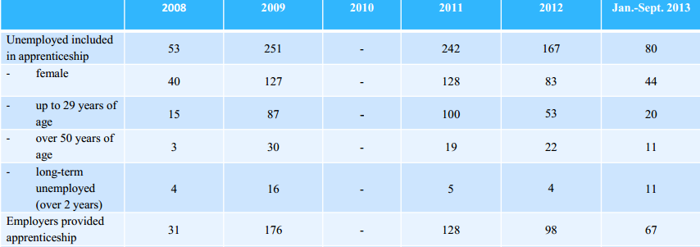

3.4 Contractual arrangements
Those taking an apprenticeship receive the minimum wage for the period of their employment. Their mentor (tutor) works in the same enterprise, has a certified qualification, and has worked for at least three years in the same occupation or trade.

The employer receives a subsidy from the National Employment Agency. This covers the apprentice’s salary and social security contributions for the time of their employment for up to twelve months. The mentor (tutor) receives additional remuneration for the period that they provide coaching which can be up to 24 months. If the employer hires the apprentice once the training is completed, the tutor can receive remuneration for an additional period of length which is equal to the subsidised period.
3.5 Bilateral cooperation
Bulgaria had a tradition of offering apprenticeships during the Communist period but this practice was abandoned. The Bulgarian government is in discussions with the Swiss government to improve the Bulgarian VET system and is preparing amendments to the 1999 Vocational Education and Training Act in order to strengthen the apprenticeship scheme.

4) Drop-out rates from school, apprenticeships and alternative pathways for young people

As shown below, the percentage of students who left VET compared with the overall number of students not completing education is significantly high in the IXth, Хth and ХІth grades from 2009/10 to 2011/12.

Students who dropped out from VET
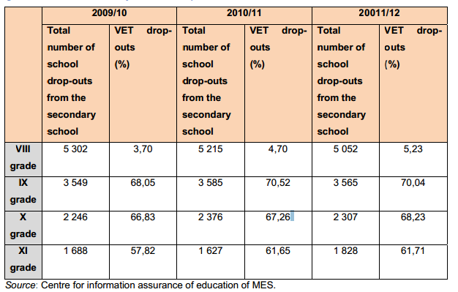

5) Future reforms in the apprenticeship system

As part of the 15 October 2013 Council Declaration on the European Alliance for Apprenticeships Bulgaria will introduce measures to increase the quality, supply and attractiveness of apprenticeships. This has the main objective of introducing Dual training in the formal VET system for young people aged between 16 and 24, early school leavers and those who drop out of education or training.

In 2013 targeted measures for unemployed people up to 29 years of age with low levels of education and without qualification were implemented through changes to the Employment Promotion Act. The Ministry of Labour and Social Policy and the Employment Agency continues to implement these measures using resources from the state budget for developing an active labour market.

The Bulgarian Industrial Association has developed an internet based and freely available Competence Assessment System (www.mycompetence.bg). It provides information on the specific skills and competences required in more than 400 occupations across 20 sectors. Working with all the stakeholders, a national competence assessment network (including employers, managers, advisers, consultants and experts from governmental) bodies has been established. The network provides the logistics for developing and implementing competence models, ensures practical mechanisms are in place for the models to be implemented and provides management services to the labour market. The establishment, management and development of the competence assessment network involves integrating the interests of employers, trade unions and the state. The coordination of research; consultation on the processes of developing, approving and implementating the competence models is organised by sector advisors from the Sector Skills Committees. The plan is to connect the network’s professional standards with the national educational standards which have to be revised and adapted to the needs of the labour market.

The Operational Programme on Human Resource Development for 2014-2020 envisages further reform to the labour market and new projects including apprenticeship measures. This programme will provide opportunities for transnational cooperation and this will help to create partnerships that can investigate and implement successful models and/or best practice in apprenticeships/Dual training.

The apprenticeship scheme and Dual training are included in the Bulgarian plan for the implementation of Youth Guarantee. This is one of the active measures for supporting the integration of young people in the labour market. The main outcomes expected from this plan are:
- for the VET system: the establishment of permanent partnerships and close co-operation between VET providers and employers; improvements in the quality of VET for young people and a better match between the skills required by employers and those developed by VET providers;
- for the labour market: ensuring a smooth transition from school to work; the provision of "second chance" training for early school leavers and drop-outs (these are groups that often do not want to re-enter the education system); improvements in the employability of the most vulnerable groups in the labour market;
- for young people over the age over 16 years: the possibility to study and work simultaneously; receive income; and enhanced opportunities to finding a job;
- for companies: training which ensures that young people acquire the knowledge and skills required for employment, including the acquisition of the specific knowledge for each company; opportunity to meet the company’s future needs in terms of a qualified labour force; and costs saving relating to the recruitment of new staff.

6) Evaluation of the existing system and potential ways to improve it

According to the Bulgarian Association of Information Technologies (BAIT) to overcome potential obstacles to setting up apprenticeship there is a need to convince the Ministry of Education and Science to include more professions in the scheme. The kind of specialisations which need to be included have to meet the ICT industry’s requirements; and the number of school students in the ICT high schools needs to be increased. In addition Computer 2000 – Bulgaria Ltd and Vivacom comment on the need for possible future apprenticeship schemes related to cybersecurity and big data. These job profiles and the associated professional training has to be developed by the partners - school and enterprise - in line with the needs of the enterprise. The professional training needs to include theory and practice.

There are some internship schemes which are used by employers in Bulgaria. Two of these internship schemes are used by VIVACOM:
- a summer internship programme when there are no assignments at the university. Interns work on a small project or they are allocated to support a company project. Each intern is assigned a mentor to help them perform their tasks. The mentors complete an ongoing assessment of each intern. In additional the interns complete an orientation (induction) programme; receive training on business communication, etiquette, and presentation skills; and participate in the company’s Corporate Social Programme. At the end of the internship the interns receive a certificate and a letter of recommendation if they have performed well. The internship lasts three months and can be extended by one month;
- an annual internship program which is conducted concurrently with the student’s university studies. Hourly work is arranged according to their study programme. The interns are involved in the day-to-day work of the team and they have operational responsibilities related to their job description. They are assigned a mentor to provide support, training and assessment. This internship lasts six months and can be extended by three months.

Based on VIVACOM’s experience of internships, a similar approach could be developed for a cybersecurity specialist and big data manager. An apprenticeship scheme should involve students during their education; they should be assigned to a company to perform specific task; and they should receive on-the-job training for the skills and knowledge required by their position. The apprenticeship should last a minimum of six months and preferably begin during the students second year of study. It is a common problem that many students in Bulgaria do not understand what is required in the job for which they study. They only realise what is required after they graduate and start to look for a job. The sooner the job expectations are made clear the better things will be for students and employers. For such a scheme to work the apprentice needs to be assigned a mentor with responsibility for training some of which should be obligatory. The focus of the training should include understanding the corporate environment, communication and coordination in a company, presentation skills, team work etc. The training provider should lead on developing these topics as they are currently not covered by education programmes and responsibility is being left to the employer.

7) Cost effectiveness analysis
There are no systematic research reports on the cost effectiveness of apprenticeship schemes in Bulgaria. However there are some examples of practice from individual companies which have evaluated their own programmes e.g. the Telerik Academy for Software Engineers’ scheme is widely regarded as a highly successful. It is very popular among young people because of the quality of the training and the positive employment outcomes as 15% of the apprentices from the company’s Software Academy were hired immediately by Telerik and more than 50% of apprentices are in employment six months after completion the programme. This programme succeeds because there is:
- strong brand recognition (Telerik was recognised as the ‘Best Employer in Bulgaria’ in 2007-2012);
- widespread publicity which increases students’ awareness of the programme;
- high quality training based on blended learning and on-site, work-based learning;
- the development of ICT skills which are in high demand in the labour market.

Revised on February 2016

EUROSTAT, Database/LFS
Youth Unemployment in Bulgaria, Yordan Dimitrov, November 2012
NEETs Young people not in employment, education or training: Characteristics, costs and policy responses in Europe- EUROFOUND, 2012
National Youth Strategy 2010 – 2020, page 10
Skills forecasts - main results-CEDEFOP
Bulgaria VET in Europe – Country report, 2013. CEDEFOP.
The European Commission defines apprenticeships as formally combining and alternating company-based training (periods of practical work experience at a workplace) with school-based education (periods of theoretical/practical education followed in a school or training centre), and lead to nationally recognised qualification upon successful completion. Most often there is a contractual relationship between the employer and the apprentice, with the apprentice being paid for his/her work. European Commission “European Alliance for Apprenticeships - Good for Youth, Good for Business”.
Systematic, long-term alternating periods at the workplace and in an educational institution or training centre. The apprentice is contractually linked to the employer and receives remuneration (wage or allowance). The employer assumes responsibility for providing an apprentice with training leading to a specific occupation. CEDEFOP
“Learning exchange on ‘apprenticeship schemes’-Ministry of labour and social policy of the Republic of Bulgaria”, Vienna, Austria – 7 November 2013
Apprenticeship-type schemes and structured work-based learning programmes - Bulgaria Cedefop’s ReferNet network 2014
Towards a European quality framework for apprenticeships and work-based learning; Best practices and trade union contributions; 2012; page 41
Learning exchange on ‘apprenticeship schemes’ - Ministry of labour and social policy of the Republic of Bulgaria”; Vienna, Austria – 7 November 2013
Towards a European quality framework for apprenticeships and work-based learning; Best practices and trade union contributions; 2012
Bulgaria VET in Europe – Country report, 2013 CEDEFOP
European Alliance For Apprenticeships Member States – Planned Reforms/Initiatives
This chapter summarise the perspective of some Digital Europe Members
Cost effectiveness of apprenticeship schemes Survey Questions for ICT sector (1 December 2014)
Cost effectiveness of apprenticeship schemes Survey Questions for ICT sector (1 December 2014)
Cost effectiveness of apprenticeship schemes Survey Questions for ICT sector (1 December 2014)
Apprenticeship and Traineeship Schemes in EU27: Key Success Factors A Guidebook for Policy Planners and Practitioners December 2013, European Commission

