

**Country – Finland**

1. **National youth employment**

Unemployment for young people aged from 15–24 in Finland has risen since the start of the economic crisis. The unemployment rate increased from 17 per cent in 2007 to 23.5%[1] by June 2015. Within this overall figure the impact on some groups, such as those with lower qualifications, has been greater. There is widespread agreement on the positive links between educational attainment and employment. Education is a shield that protects people from unemployment: the greater an individual’s level of education, the lower is their probability of being unemployed (ILO, 2012)[2]. This is supported by evidence from the OECD (2012)[3] which shows that a higher level of education provides an insurance against unemployment and makes it more likely that an individual will stay in employment and maintain their earning power in difficult times. In general those with at least upper secondary education are much more likely to be employed; participate in the labour force; and have higher earnings compared to those with lower levels of education.[4]

In the EU, the proportion of young people aged 15–24 years who were not in employment, education or training (NEETs[5]) was 12.9 per cent in 2011; and for those aged 15–29 years the figure was 15.4 per cent. The comparable statistics for Finland were 8.4 per cent and 10 per cent.[6] In all Member States the percentage of NEETs with lower educational levels is much larger than those with tertiary level qualification (typically graduates). However it is interesting to analyse those who have achieved a tertiary degree and then ended up as NEETs. The proportion of those who completed tertiary education and subsequently fail to gain employment, or pursue education or training is marginal in many Member States including Finland where it is less than five per cent of graduates. Nevertheless when an analysis is completed of all those who are in the NEET category in Finland, more than 25 per cent of individuals have tertiary level education.

More than 60 per cent of NEETs in Finland have previous work experience. This is a significant contrast to the situation in almost half of the Member States where the majority of NEETs declared that they have never worked. Associated with these figures is the high level of ‘discouraged workers’ in Finland. More than 40 per cent of the inactive NEETs in Finland would classify themselves as ‘discouraged’ contrasting with other European countries where there are many NEETs who are low skilled and there are few discouraged workers.

At the European level, the share of Gross Domestic Product (GDP) lost due to the non-participation of young people in the labour market increased from 0.96 per cent in 2007 to 1.21 per cent in 2011. In Finland the figures are better than the European average but the situation deteriorated from 0.88 per cent of GDP in 2007 to 1.07 per cent of GDP in 2011.

Employment of young people

The majority of the Member States have experienced falls in youth employment since the start of the recession. In Finland youth employment fell from 45 per cent in 2007 to 40 per cent in 2011. However there are some important characteristics of youth employment to consider e.g. the importance of part-time and temporary employment which each affects 40 per cent of young people[7]. In 2011, 41 per cent of 15-29 year-olds who were not in education and had an upper secondary qualification were employed, compared with 10% for those with a lower qualification (OECD average: 43% and 17%, respectively).[8]

Skill Needs**[9]**

CEDEFOP has many initiatives to forecast skills needs. Through its Skillsnet network members are involved in activities related to the identification of skill needs such as forecasting, employer surveys and sectoral analysis. CEDEFOP uses employers’ surveys as a tool to identify skill needs and skill gaps at the workplace level. The aim of their work is to develop a tool or instrument to reliably identify skills, competences, occupations and qualifications that will be needed by public and private enterprises in Europe in the future. This information is used as an input into a broader analysis of skill needs. Using these studies of skill needs and job opportunities in Finland it is possible to predict:

* expansion in the sectors of Business and other services, Distribution and Transport;
* an increased occupational demand for Professionals, Technicians, associate professionals and elementary occupations;
* up to 2025, an increase in the employment of individuals with high levels of education and a corresponding fall in the employment of people with low levels of education.

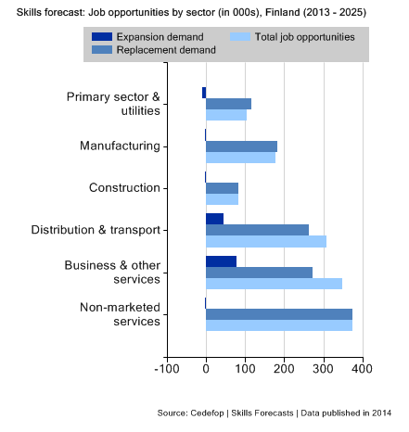

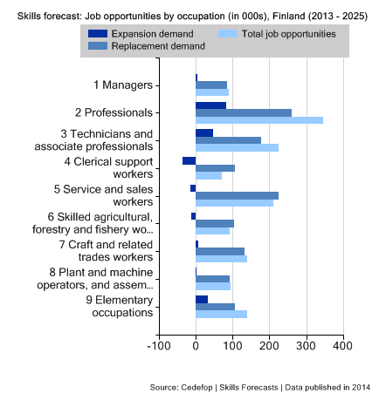

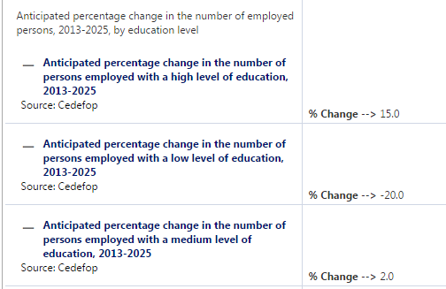

Source: EU Skills Panorama

**2) The VET system**

A major reason for the development and economic growth experienced by Finland has been education and training. Over the last 10 years Finland has reformed its education policy and has stressed the importance of transition between the different levels of education e.g. it is seen as important that a high percentage of young people progress to the upper secondary level after completing their basic education. Permeability and equal opportunities (education is free from the pre-primary to the higher education level) are seen as the foundations of the education and training system. Learners who take a vocational route are eligible to enter higher education on the same basis as those who completed upper secondary education.

The reform of the education system has led to the development of competence-based qualifications which have been designed in close cooperation with employers and other stakeholders representing the world of work. The aim has been to create qualifications and a qualification structure, which are clear and meet the needs and demands of the labour market. Almost all VET provision is regulated by the government and the qualification requirements for each profession are decided at the national level. Most of the funding for VET training is provided by the State and local authorities.

VET starts at the upper secondary level of education. All students complete the same compulsory education and then select general or vocational upper secondary education or training. The students’ selection is mainly based on their grades from their basic education. VET providers may have their own selection criteria; these include relevant work experience, entrance or aptitude tests. More than 40 per cent of young people start their vocational upper secondary studies immediately after basic education. The most popular subject areas are technology, communications, transport, social services, health and sports. For those who take upper secondary VET three pathways are available: school-based programmes; competence-based qualifications and apprenticeship training.

**The number of VET students in 2007 and 2010***[10]*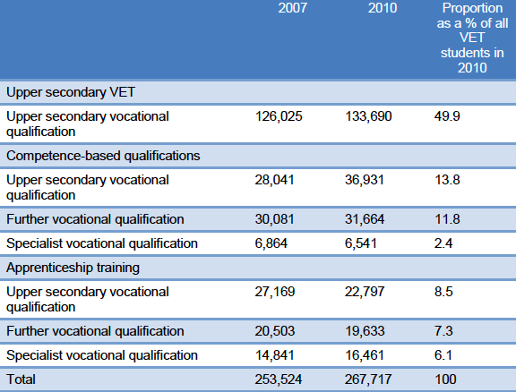

*Source: Statistics Finland (Refernet 2012)*

50 per cent of young learners complete their upper secondary vocational qualifications in school-based programmes. Other vocational pathways (competence-based qualifications and apprenticeship training) are more likely to be taken by adults.

**Involvement of the labour market in developing qualifications**

The requirements for vocational qualification are developed in close co-operation with stakeholders. These are national requirements which are based on a learning outcomes approach. Since the early 1990s this approach has helped to ensure that qualifications support flexible and efficient transitions from education to the labour market, as well as providing opportunities for individuals to further their own development and change careers. Representatives from the social partners are involved in setting the national objectives for the Government programme set out in the Development Plan for Education and Research. The social partners are involved in predicting the national need for skills and education and the regional needs through the Training and Qualification Committees; various advisory committees and consultation processes. The representatives are closely involved in defining the vocational competence requirements of qualifications as well in drawing up the expectations for each qualification at a national level. At the regional level, enterprises are involved in the design of local curricula; organising and planning training and skills demonstrations[11]; regional committees; assessing skills demonstrations in upper secondary qualifications and competence tests in competence-based qualifications.

The overall approach is one that seeks to create a continuous improvement and involvement process that connects education and the labour market.

1. **The apprenticeship system**

**3.1 Definition of apprenticeships[12]**

Apprenticeships in Finland are a work-based form of VET and an alternative way of getting a vocational qualification. They provide opportunities to achieve a vocational qualification, a further vocational qualification or a specialist qualification which gives trainee access to higher education. The system is organised in the workplace and includes practical work assignments supplemented by theoretical training provided in a vocational institution. Apprenticeship training is available for young people and adults but, compared to situations in other European countries, the apprentices are mainly adults. About 80% of the apprentices are over 25 years.

**3.2 Legislative framework**

The apprenticeship system has a long tradition which, for a long time, was restricted to a few vocational sectors. At the beginning of the 1990s new legislation allowed apprenticeship training in all vocational qualifications and sectors. As a consequence apprenticeship training has become much more popular in recent years. There are 369 qualifications which can be achieved through apprenticeship training. There is also, in some situations, a tailor-made training programme to respond to the needs of a specific job – this pathway does not aim to offer an official qualification.

As part of the training, a placement abroad can be recognised if the learner acquires skills and knowledge that meet the needs of the apprenticeship trade. Mobility which is part of the initial vocational training for apprentices has to be approved by the employer and by the training authorities in order for it to be integrated into the apprenticeship training. This recognition is in line with the principles of the ECVET Recommendation (the European Credit System for Vocational Education and Training).

Approximately 70 - 80 per cent of the learning takes place in the workplace under the guidance and instruction of an on-the-job trainer(s). The apprentice’s theoretical training is provided by a vocational institution. The length of apprenticeship depends on previous studies, existing skills and work experience.

**3.3 Number of apprentices**

Twenty per cent of those in vocational training programmes are completing an apprenticeship. In 2012 approximately 55,600[13] people were taking an apprenticeship. This was down from more than 70,000 individuals in 2008 – this reflected the financial cuts experienced by the public sector which funds part of the apprenticeship training, and the slowdown in business activity. It is important to note that adults comprise an important group of apprenticeships – they are often working or have experience of work but they lack the formal skills needed for their job and they need to gain the necessary diploma or qualification.

**3.4 Contractual arrangements**

Apprenticeships are based on a written fixed-term employment contract between an employer and an apprentice who is at least 15 years old. Most trainees are employed when they start their apprenticeship training. As part of the contract employers pay apprentices a wage for their time in the workplace. This wage is set by each sector’s collective agreement[14]. The theoretical training which is provided by a training institution is free and funded by the State. During their theoretical training learners receive social benefits (a daily allowance, allowance for accommodation and travel expenses etc.). The employer receives funding from the institution providing the theoretical apprenticeship training – this is to cover the cost of training provided in the workplace.

**3.5 Cooperation**

There is a national programme to export Finnish solutions in education and training. The initiative, Future Learning Finland[15], is coordinated by FINPRO which is a trade and investment development organisation. It is supported by the Ministry of Education and Culture, the Ministry of Employment and Economy and the Ministry for Foreign Affairs. It offers global learning solutions in five fields: teacher training; vocational training; learning environments; university research and Edutech (ICT in learning and education). Its 70 members include universities, vocational institutions, foundations, associations and private companies. In the area of vocational training, Future Learning Finland offers bespoke solutions to education and training issues faced by other countries.

**4) Drop-out rates**

The drop-out rate (10 per cent as average) from VET programmes is low compared to the European average[16]. Despite this, actions to reduce dropout rates are a major concern for education policy. The drop-out rates from VET are higher than those experienced in general upper secondary education; and vary between study fields. In the humanities and education it is 6 per cent while in the natural sciences field it is 13.5 per cent. To reduce drop-out rates there is an emphasis on flexibility and the development of individualised pathways. These help to improve completion rates and make it easier for individuals to complete their qualifications if there is an interruption in the learning process. Learners can receive certificates for completing individual modules or units in a qualification. Another measure is to take account of the drop-out rate when allocating State funding to the VET training providers.

**5) Recent reforms to the apprenticeship system**

The Government is committed to implementing a social guarantee for young people. This will ensure that everyone under 25 and every new qualification-holder under 30 will be offered a job; on-the-job training; a study place; or time in a workshop or in rehabilitation within three months of becoming unemployed. In addition there is an education guarantee which is part of the social guarantee. This means that every school-leaver is guaranteed a place at general upper secondary school; in vocational education and training; or in apprenticeship training.

“As *a part of implementing the Youth Guarantee, the Ministry of Education and Culture will start an action program aiming to renew the apprenticeships scheme as well as work-based learning of young people. The aim of the program is to increase learning by apprenticeships and to develop education models that combine both training institution –based vocational education and training and the apprenticeships. Also models combining flexible forms of vocational education and working are being developed for the young people. The actions are targeted at young people under 25 years of age, and without upper level vocational qualification.[17]"*

To support this guarantee, the State has taken action to increase apprenticeships and work-based vocational education. These actions include:

* developing a pre-period programme before individuals begin an apprenticeship;
* training more trainers of apprentices;
* increasing the number and size of the grants to employers;
* promoting work-based learning for young people;
* strengthening more flexible combinations of work and education.

This programme was developed through social dialogue and has involved all the stakeholders including employers and trade unions, educational administrators, ministries and VET providers.

**6) Evaluation of the existing system and potential ways to improve it**

According to the social partners **[18]** the apprenticeship system works quite well in Finland and there is a robust institutional and regulatory framework. The system functions well especially in the field of adult education, because "the basic model" of apprenticeship focuses on educating adults and it is well-known. Employers are quite pleased with the model. The system provides a good opportunity to entrepreneurs to develop the skills and qualifications needed for their business as well being an important way to recruit staff.

The apprenticeship system is developed by the Ministry of Education, National Board of Education and social partners (labour market/business). VET providers and public authorities share information on apprenticeship. Social partners have a developmental role and participate in national projects to develop apprenticeship. The vocational qualifications framework and individual qualifications are developed through co-operation with social partners and companies in order to ensure that they support learners to make an efficient transfer to the labour market. However SMEs find the governance arrangements bureaucratic and the apprentices’ wages relatively high (apprentices are paid according to the general agreement in each industry).

The main challenge is to increase the number of young people taking an apprenticeship. At the national level there are projects relating to the apprenticeship system for young people. They aim to develop the system so it becomes more attractive to young people and their parents. Often the image of apprentices is not good and parents/young people often do not know that an apprenticeship is a different way of getting a vocational qualification. Entrepreneurs agree that the apprenticeship for the young is not sufficiently driven by the needs of enterprises. The biggest challenge is the amount of compensation given to the entrepreneur. This is not sufficient in the current model as the pay of the apprentice is high and the compensation for the employer is low.

Apprenticeship training for young people should take account of the skills and requirements of the employer and the level of productivity needed by the sector. An increased level of compensation for employers could be linked to an increase in the level of the skills that are expected from an apprentice – these could be verified in competence-based examinations. Compensation for apprenticeship training should be defined for each sector. The apprenticeship system should be seen as having equal status with the other educational models (such as the work or school based models).

**7) Cost effectiveness analysis**

Apprentices are financed by the state. The annual subsidy paid to the organiser for one apprentice is calculated from the average cost of vocational training in Finland. At the moment[19], the state subsidy for an apprentice pursuing an initial vocational qualification is 63 per cent of this average cost, and this is used to buy training from a vocational school, compensate the employer for training, and cover the cost of student welfare benefits if needed. In the case of advanced vocational qualifications the state subsidy is lower although the amount can vary from year to year at the discretion of the Ministry of Education and Culture.

State subsidies for apprenticeship training are paid per student and these are lower than other forms of VET. Employers make a significant financial contribution to the training by paying a salary to the apprentices. In addition students contribute to social welfare services by paying taxes. From this it may be reasonably concluded that apprenticeships are somewhat cost-neutral from the point of view of society. Employers’ comments on apprenticeships were summarised in a 2013 research report[20] – the percentage of employer responses falling into the categories good and very good (the number of responses is given in brackets):

* workplace needs were taken into account in the planning of education 86% (5970);
* basic training supported learning on the job 90% (3007);
* apprenticeship training promoted the development of student skills 93% (3750);
* apprenticeship training is a good form of VET 94% (3740).

In relation to the Apprenticeship Training at Vocational Upper Secondary Level (IVET and CVET), the 2013 Guidebook for Policy Planners and Practitioners (Apprenticeship and Traineeship Schemes in EU27: Key Success Factors) made the following comments:

* in 2011, 25% (13,270 apprentices out of 51,700) completed the full vocational qualification; 6.9% dropped out (3,570 apprentices);
* effectiveness of employment outcomes: in 2011, 71% of IVET participants were employed and 12% were unemployed. Three out of four of the unemployed were under 30 years of age. There is no data specifically on the employability outcomes of apprenticeship students;
* cost effectiveness: the cost of apprenticeship training in VET was €6,000 per trainee and the cost of apprenticeship training in vocational further training was €3,300 per trainee. Total costs increased by 3.1% compared with the previous year (National Board of Education, 2012).

This report also highlighted the following success factors of the apprenticeship scheme:

(i) individual study plans, where previous work and education experience is recognised; (ii) the opportunity to complete national vocational qualifications through apprenticeship training (iii); the social partners are involved in sectoral qualification committees.

*Revised on August after the cluster seminar*

Annexe A

 *English language supplement of the Magazine Osaaja*

1. <http://ycharts.com/indicators/finland_youth_unemployment_rate_lfs> [Accessed 11-8-15]
2. NEETs - Young people not in employment, education or training: Characteristics, costs and policy responses in Europe EUROFOUND 2012
3. Education at a Glance 2013-OECD indicators
4. Finland Youth Unemployment Rate Ycharts. <http://ycharts.com/indicators/finland_youth_unemployment_rate_lfs> [Accessed on 10-12-14]
5. The "share of young people not working, studying or performing compulsory military service" used by Statistics Finland's Labour Force Survey describes the share of young people aged 15 to 24 who are not working, studying for a degree or qualification, attending course training or performing military or non-military service compared to the entire age group. The figure of Statistics Finland's Labour Force Survey differs slightly from the almost corresponding NEET rate used by Eurostat.
6. NEETs - Young people not in employment, education or training: Characteristics, costs and policy responses in Europe EUROFOUND 2012. <http://eurofound.europa.eu/publications/report/2012/labour-market-social-policies/neets-young-people-not-in-employment-education-or-training-characteristics-costs-and-policy> [Accessed on 10-12-14]
7. NEETs - Young people not in employment, education or training: Characteristics, costs and policy responses in Europe EUROFOUND 2012. <http://eurofound.europa.eu/publications/report/2012/labour-market-social-policies/neets-young-people-not-in-employment-education-or-training-characteristics-costs-and-policy> [Accessed on 10-12-14]
8. Country Note –Education at Glance, 2013, OECD
9. Skills forecasts - main results-CEDEFOP
10. <http://www.cedefop.europa.eu/files/8055_en.pdf>. [Accessed on 10-12-14]
11. Skills demonstrations are the means by which individuals are assessed in relation to the competences required from a qualification. Each learner demonstrates their skills and they are assessed by the VET provider, an employer and through a self-assessment process.
12. The European Commission defines apprenticeshipsas formally combining and alternating company-based training (periods of practical work experience at a workplace) with school-based education (periods of theoretical/practical education followed in a school or training centre), and lead to nationally recognised qualification upon successful completion. Most often there is a contractual relationship between the employer and the apprentice, with the apprentice being paid for his/her work. *European Commission “European Alliance for Apprenticeships - Good for Youth, Good for Business”*.
13. <http://www.stat.fi/til/opiskt/2012/opiskt_2012_2014-01-29_tie_001_en.html>
14. Employers pay apprentices approximately 80 per cent of the wage earned by a skilled worker in the sector. This is defined in sector-specific collective agreement. We should note that Finland is one of the countries in the EU without a national legal minimum wage.
15. <http://www.futurelearningfinland.fi>
16. Finland Vet in Europe - Country Report - Refernet 2011 CEDEFOP
17. European alliance for apprenticeships Member states – planned reforms/initiatives
18. Confederation of Finnish Industries - EK - SY - The Federation of Finnish Enterprises - CEEP Questionnaire on the federation’s views on apprenticeships - BUSINESSEUROPE/UEAPME/CEEP
19. Finland in Focus, towards 2020 in VET, CIMO, Leonardo da Vinci Programme. <http://www.cimo.fi>
20. Apprenticeships in English, 2013, <https://www.omnia.fi/documents/35800/0/Apprenticeship+in+English/3c38c9dd-18be-4bca-99ce-c950605b0287>. [Accessed 0n 16-3-15]