

**Country – France**

**1) National youth employment**

The unemployment rate in France for young people under the age of 25 years was 25.2% in December 2014 compared to 21.4%[1] in the EU28 countries. The unemployment rate among French youths aged from 20-24 hasn’t fallen below 16% in almost 30 years. This suggests that an entire generation has been affected by high levels of unemployment.

In 2013 the NEET (young people not in employment, education or training) rate was 11.2% which was below the EU28 average of 13%.[2] Considering the significant variation in the NEET populations across Europe, EUROFOUND has classified France as having below average NEET rates. In France most NEETs are registered as unemployed, have previous work experience and medium level of skills. As a share of GDP, the economic loss at the European level associated with the non-participation of young people in the labour market increased from 0.96% in 2007 to 1.21% in 2011. In France this economic loss represented 0.92% in 2008 and 1.11% in 2011 of GDP.[3]

Employment of young people

In France the youth employment levels remained at almost the same level from 2007-2011(30%)[4] with a decrease to 25.5% in November 2013 for 15-24 years old.[5] When we look at the composition of employed young people in 2011 we see that in France a large majority of young people are employed in salaried jobs and less than 5% are self-employed. Compared to the EU27 countries young people in a salaried job make up approximately 92% of those who are working.

At a European level, the proportion of young people working part time has continued to grow in recent years. While in 2002 part-time work represented 21.5% of youth employment; in 2011 it represented almost 30% which corresponds to 5.8 million young people. In France the proportion of young people working part time was about 20% in 2007 and 2011. Temporary employment in France is also considerably higher than the EU average (55% compared to 40%). Youth employment in manufacturing has fallen in the majority of the countries in Europe but in France the youth employment rate for this sector has remained unchanged.

Skill Needs[6]

CEDEFOP has many initiatives to forecast skills needs. Through its Skillsnet network members are involved in activities related to the identification of skill needs such as forecasting, employer surveys and sectoral analysis. CEDEFOP uses employers’ surveys as a way to identify skill needs and skill gaps at the workplace level. The aim of their work is to develop a tool or instrument to reliably identify skills, competences, occupations and qualifications that will be needed by public and private enterprises in Europe in the future. This information is used as an input into a broader analysis of skill needs. Using these studies in France it is possible to predict:

* some increase in demand in the sectors of business and other services, non marketed services, distribution and transport, and construction;
* an increase in the demand for the following occupations: technicians and associated professionals, professionals, managers, elementary occupations, and service and sales staff;
* upto 2015, an increase in the employment of people with high levels of education and a decrease in the number of people who are employed with low level of education.

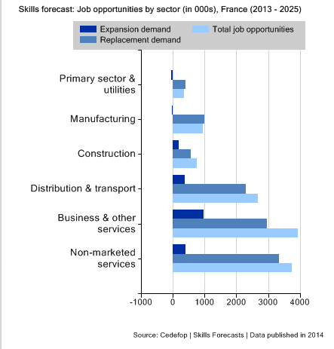

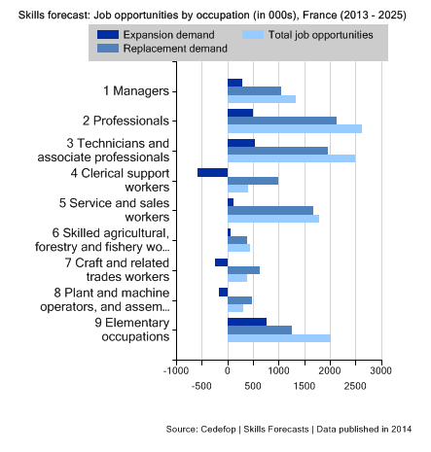

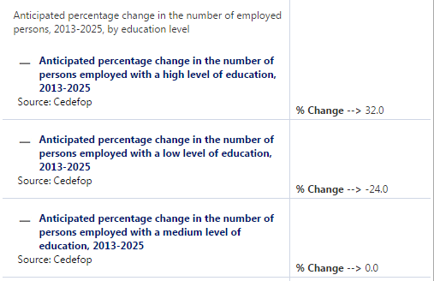

Skills Panorama/ CEDEFOP

**2) VET system in France**

Vocational education and training in France (which is provided by the state) is based on two approaches which are relatively independent of each other:[7]

* initial vocational training which is offered to young people in full-time education (school and university) and apprentices;
* continuing vocational training which is offered to adults in the labour market and young people who have left or completed initial education.

In France education covers all ages and includes opportunities for vocational and alternate training in either a school context or under an employment contract. In recent years the links and cooperation between schools and business has increased. The French system of initial education and training is compulsory from the age of 6 to 16. It is organised in three levels:

* first level education - pre-primary and primary education;
* secondary education which is divided into two stages with a compulsory first stage of secondary education;
* higher education.

The first stage of secondary education is provided in the *colléges* (junior high schools) and lasts 4 years (from the age 11 to 15). The national brevet des *colléges* (lower secondary level diploma) is used to assess the knowledge and skills acquired by students at the end of lower secondary school. This qualification is not a condition for accessing the second stage of secondary which is provided in *lycées* (senior high schools) for students aged from 15 to 18. There are three educational streams in the *lycées*: the general stream; the technological stream; and the vocational stream. The national baccalaureate marks the end of secondary education in the general and technological pathways.

There are two sectors in higher education: the university sector which consisting of public institutions which do not usually have a selective entry system; and the non-university sector consisting of *préparatoires* and *grandes écoles*. Entrance to these is based on a selective entry examination.

In the French VET system the Ministries of National Education and Higher Education are the main competent bodies that award degrees on behalf of the State - but they are not the only ministries or organisations with this responsibility. Other ministries are involved in education and VET and they, alongside other organisations, can issue certificates e.g.:

* the Ministry of Agriculture organises occasional agricultural qualifications that can be accessed through schools, apprenticeships, lifelong learning programmes and accreditation of work experience (VAE - *validation des acquis d'apprentissage*);
* the Ministry of Labour, Employment Vocational Training and Social Dialogue currently has approximately 260 professional qualifications (from EQF Level 3 to 5) in most professional sectors. Professional qualifications are aimed at anyone who is no longer in education, employed or looking for work. A professional qualification can be acquired through a VET course or through the accreditation of work experience. The course generally involves time in a company. The qualification is awarded following the competition of a continuous (or discontinuous) VET course. To obtain the qualification applicants prepare a summary of their work experience (dossier de *synthèse de pratique professionnelle*) and take a test which is described in the qualification’s criteria. The training course must take place in a training centre approved by the Minister of Employment, or on an AFPA *- Association* *pour la formation des adultes* campus. At present, AFPA is the only training body legally authorised to award the Ministry of Employment’s vocational qualifications. The same qualification can also be obtained through a leaner receiving accreditation of their work experience (VAE);
* the Ministry of Social Affairs awards “State qualifications” for the social work professions. Social work qualifications can be accessed through standard education programmes (including apprenticeship), lifelong learning programmes and by accreditation of work experience (VAE). The specialist institutions (around 350) that provide training for these qualifications are located across France and are usually managed by non-profit organisations;
* the Ministry of Health awards 12 qualifications which provide access to specific jobs in the paramedic sector. The Ministry of Health qualifications provide training which is compulsory for entry to a single profession. Entry to these training courses is generally controlled by an examination and some are highly selective. Focusing strongly on the development of practical skills, the training for health work qualifications consists mainly of work based learning and includes job placements and internships;
* the Ministry of Culture primarily awards higher education qualifications (EQF Levels 5 to 7) in the fields of architecture, plastic arts, performance art, cinema and audio-vision. The Ministry’s qualifications are not usually accessible via apprenticeships
* the social partners via the vocational branches;
* public or private establishments in their own name;
* consular establishments i.e. establishments placed under the aegis of the chambers of trades and crafts, the chambers of commerce and industry, and the farmers’ associations;
* those certifying institutions that have been authorised by a French ministry to issue certifications.

In France there is a process of “Professional certification” which enables an individual’s professional skills to be assessed against a set of criteria. Following this process an individual receives a document which confirms their professional skills and refers to a set of standard descriptive documents. These professional certificates include vocational qualifications and diplomas awarded on behalf of:

* the French ministries in a framework that includes social partners;
* training organisations, the vocational consular chambers and the ministries that have no “consultative vocational Committee” and are covered by an examination and an opinion from the CNCP, followed by a decision made by the minister in charge of vocational training;
* the social partners under their own responsibility, but which are covered by an opinion from the National Vocational Certification Committee (CNCP). These are vocational qualification certificates (*certificat de qualification professionnelle - CQP*)

The skilled craft chambers issue professional certificates which have been developed through strong cooperation with professional organisations. These certificates can be from EQF 3 to EQF 5. In addition EQF level 6 bachelor degrees and certificates for managing small companies are delivered in partnership with universities and technological institutes as part of the framework of the “regional university of crafts” ([www.e-urma.fr](http://www.e-urma.fr))

These processes for certifying individuals’ achievement have led to the establishment of specific organisations and procedures in order for the certificates to be included and classified in the National Register of Vocational Certifications (RNCP). To be included in the RNCP it must be possible to acquire the qualification through the validation of non-formal and informal learning. Registration is required in order to receive funding.

Social partners in France have an essential role in the regulatory, political and financial aspects of VET. The social partners show their commitment to VET in different ways e.g. In defining the training policy of a sector; participating in the “consultative (advisory) vocational committees” where they are involved in the creation and development of the ministry of education’s VET qualifications; managing the training funds of sectors (through the organisations that they manage); promoting specific training actions such as those programmes aimed at members of the public with low qualification levels; liaising with very small companies in order to decide whether to create or withdraw a sector’s qualification. In addition ministries develop certificates based on the opinions of consultative bodies which may be professional consultative committees (CPC - *Commissions professionnelles consultatives* for the Ministries of National Education, Employment, Social Affairs, Agriculture, Youth and Sport, and Culture).

The differences between VET and higher education qualifications in the French National Qualification Framework are less clear than in many other European countries. This indicates there is a wish to promote vocationally and professionally oriented qualifications at all levels. As reported in the *Times Higher Education[8]* “French employers also grumble that university graduates do not acquire skills that are transferable to the workplace. They say that candidates lack vital soft skills, such as IT qualifications, knowledge of English and presentation or project management skills.” Although a significant number of French young people are looking for work, 35% of French employers say they can’t find enough employees with the right skills. For 28% of employers this is a common reason why vacancies remain unfilled.

It is important for the qualification system to anticipate the changing needs of business needs and not just react to the current situation. In France a system of “study contracts” (*contrats d'études prospectives*) are a key means for the state and social partners to collaborate in analysing the future skills needs of companies. There is an observatory which helps to identify training needs by collecting regular feedback from 40.000 enterprises on recruitment. Around 25% of the companies comment that they find it difficult to recruit the right people, and it can be assumed that jobs are lost due to this mismatch problem. Although it is complex for companies to anticipate the skills they need in the next three or four years, these forecasts are seen as vital in order to fine-tune training in a rapidly changing context.

**3) Apprenticeship training**

**3.1 Definition of apprenticeship**[9]

Together with the full-time school education programmes, there is an apprenticeship programme based on alternate training. The French apprenticeship - *apprentissage* - aims to enable young people (aged 16‐25 years) to follow a training course which combines theoretical and practical elements in order to achieve one of the following recognised vocational qualifications - the Vocational Baccalaureate; Diploma of Vocational Studies (BEP), Certificate of Vocational Aptitude (CAP), Higher Technical Diploma (BTS), or University Technological Diploma (DUT).

All vocational certificates are registered in the national directory of professional qualifications (RNCP - *Répertoire national des Certifications Professionnelles*). This includes all secondary or higher education certificates and the vocational qualification certificates for apprenticeships (CQP) created by the professional branches.

A number of different organisations are involved in the apprenticeship:

* regional authorities (*Conseil Régional*) define the training offer in line with the regional needs and in cooperation with local social partners. The regional authorities establish agreements with the apprentice training centres (CFA) for their funding;
* the state has a role as a regulator and supervisor through the Ministry for Labour and Employment;
* the social partners are fully involved in the apprenticeship system through their role on the boards of governors of the Apprentice Training Centres (*centre de formation d’apprentis* CFAs) and their membership of the Commissions set up within the OPCA *– (Organismes Paritaires Collecteurs Agréés* - Accredited Organisations for the Collection and Distribution of Training Funds) which manages the funds which cover the cost of company training;
* the companies which fund apprenticeships through a specific tax (*le taux d'apprentissage).* This is paid by the enterprises to the collecting organisation (OPCA) even if the company does not employ apprentices;
* the Chambers of Commerce, Chambers of arts and crafts and the Chambers of Agriculture have an important role in advising employers. They check and register apprentice agreements. They also develop communication plans and activities to motivate companies to take apprentices.

An apprenticeship is a blend of on-the-job training and further education. One or two days per week (a minimum of 400 hours per year) are spent at an Apprentice Training Centre (CFA). An apprenticeship, depending on the type of profession and the qualification, can take from one to three years.

The apprenticeship contract - a type of employment contract - gives the learner the status of an apprentice which makes the learner a company employee and a student in an Apprentice Training Centre (CFA). They receive a salary as an apprentice – this includes the time learners spend in the CFA. Training takes place both in the workplace and the Apprentice Training Centre (CFA). The apprentice contract is signed by the apprentice and the employer and it is subject to the existing labour law and collective agreements. In 2011 around 295,000 apprenticeship contracts were signed - companies with less than five employees have issued 39.7% of these contracts. The SMEs (up to 50 employees) have signed 77% of these apprenticeship agreements.

The apprenticeship contract offers a good way to enter employment: some 61% of apprentices go directly into employment and three years after completion 86% of apprentices are employed. Apprenticeships are widely promoted by "Apprenticeship Developers" in the Chambers of Commerce who have made contact with more than 140,000 enterprises between 2009 and 2012.[10]

An apprenticeship in higher education (HE) was introduced in France in 1987. This allows Higher education (HE) institutions offer apprenticeship based learning pathways that lead to HE diplomas and degrees. These apprenticeships are offered mainly in engineering and business schools. Higher education apprentices benefit from the same legal status as other apprentices. They are covered by provisions in the labour legislation and the collective agreements that apply in the enterprise where they work.

**3.2 Legislative framework**

Apprenticeship in France has a long tradition. The first laws regarding apprenticeships were passed in 1851. From 1919 young people had to complete 150 hours of theory and general lessons in their subject each year. This minimum training time increased to 360 hours a year in 1961 and 400 hours in 1986. The first training centres for apprentices (Centres de formation d'apprentis - CFAs) were set up in 1961.

Since July 1971 apprenticeships have been part of the French initial VET system. In 1986 the age at which an individual could for start an apprenticeship was raised from 20 to 25. From 1987 the range of qualifications achievable through an apprenticeship was widened to include the *brevet professionnel* (certificate of vocational aptitude), the *bac* *professionnel* (vocational baccalaureate diploma), the *brevet de technicien supérieur* (advanced technician's certificate), engineering diplomas, and master’s degree.

As mentioned earlier the apprenticeship combines training with an employer and training at a CFA. The apprentice spends 60% to 75% of their time in a company. They are guided by a supervisor who assigns their tasks to the apprentice and shares their knowledge and expertise. Training in a CFA lasts for at least 800 hours over two-year CAP programme and at least 1,850 hours for the three year vocational baccalaureate. The curriculum is organised by the CFAs where two thirds of the course focuses on general and technical training. The remaining third is set aside for practical training.

The apprentice’s remuneration is a percentage of the minimum national salary (*smic* - *salaire minimum*[11]) and depends on the apprentice's age and how far they have progressed in their training. Some sectors like hairdressing and building have collective agreements with more favorable provisions.

Apprenticeships are funded through a complex mechanism involving central government, regions and enterprises. Support to enterprises is provided by the State and the Regions - this is based on a range of incentives which include public subsidies, tax benefits and exemptions from taxes and social security contributions.[12] The role of the Regional Councils is increasing as they now provide incentives to enterprises with fewer than 250 employees and less than 11 employees[13] to recruit a first apprentice or an additional apprentice. If a company has fewer than 11 employees (TPE - *Très petite enterprise*) there is an exemption from paying the social security contributions. For companies employing more than 11 staff there is a partial exemption from the social security contributions. Companies with more than 250 employees receive a bonus or a financial penalty depending on whether they are engaged or not in apprenticeships.

In line with the government’s 2015 objectives, 5% of employees in companies with more than 250 staff should be apprentices. If companies do not meet this objective they pay a tax based on their total payroll costs. There is a further payroll tax for companies that employ more than 2,000 staff if they don't reach the 5% objective. If a company exceeds the 5% objective they receive a bonus from the State.

Public enterprises and the public administration are involved in the apprenticeship system. As a way of renewing and revitalising public administration there are targets for recruiting apprentice - 4000 apprentices from September 2015 and 6,000 in September 2016.[14]

SMEs remain the main users of apprenticeship and they issued 74% of the new contracts in 2015. Within SMEs the service sector is the biggest user of apprenticeship contracts.[15]

**Employment of apprentices based on the size of the enterprise (%)**

**2010 2011 2012 2013 2012/13**

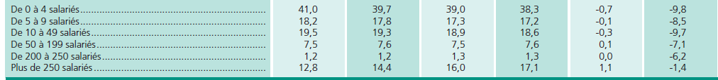

Dares, base de données issue du système d’Ari@ne de gestion informatisée des contrats d’apprentissage

**3.3 Some work based learning programmes**

In France as well as an apprenticeship contract there is another type of alternance contract called the "*Contrat de professionalisation*". This allows the entry or return to employment for young people under the age of 26 without professional qualification or those who wish to complete their training at any level. It is available to job seekers aged 26 years and over who wish to obtain a Vocational Qualification Certificate (CQP: *Certificat de Qualification Professionnelle*) or qualification covered by a collective agreement and registered within the National Qualifications Framework (NQF).

The number of people signing each type of contract is as follows:

|  |  |  |  |
| --- | --- | --- | --- |
|  | **2010** | **2011** | **2012** |
| “Contrat d’apprentissage” | 287,719 | 295,044 | 297,768 |
| “Contrat de professionalisation” | 147,990 | 173,185 | 158,284 |

Framework of Actions on Youth Employment Annex-Case Studies

**3.4 The number of students**

From 1992-2011 approximately 4,630,000 apprenticeship contracts were signed. In 2011 more than 295,000 new contracts were signed. Apprentices are an important group of learners in France even though the national targets are not being met. In 2013 there was a decline in the number of new contracts with 273,000 new apprenticeships in the private sector – this was a fall of 8% compared to 2012 and followed two years when there had been a slight increase. The number of apprenticeship in the public sector is also declining, (at a slower rate of decline than in the private sector) and in 2013 the numbers fell by 3%.[16] These falls are due to several factors - the slowdown in the economy and the deterioration in the labour market from mid-2011 is one of the main reasons causes for this decline. However there is a concern that this fall partly reflects the choice of young people who, when they complete the "*collège"*, prefer to move to general education. The fall in the number of signed contracts continued in 2014.

**Number of new apprenticeship contracts according to the level of qualification**

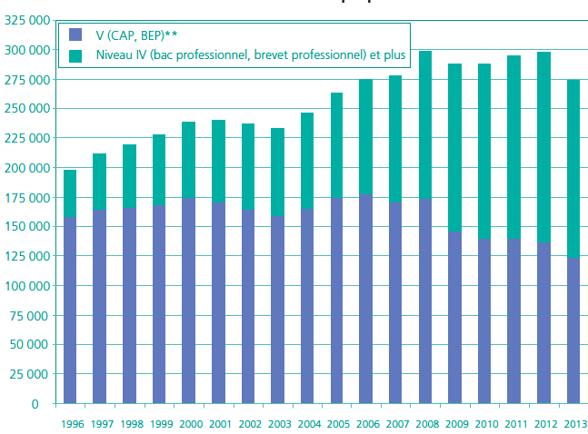

*Dares, base de données issue du système d’Ari@ne de gestion informatisée des contrats d’apprentissage.*

**Apprenticeship contracts in each sector (%)**

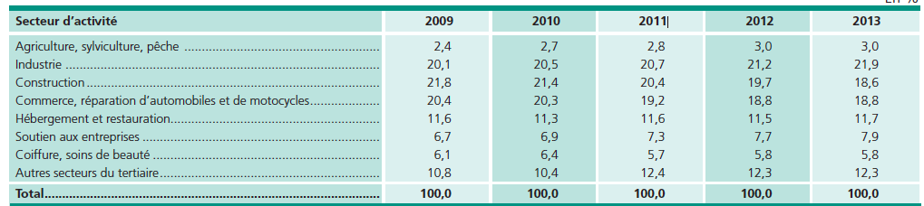

*Dares, base de données issue du système d’Ari@ne de gestion informatisée des contrats d’apprentissage*

**3.5 Contractual arrangements**

Apprenticeships are based on an employment contract signed by the employer, the apprentice and the training institution. The length of this contract varies from one to three years depending on the profession and qualification. The maximum length of a contract can be extended to four years in the case of a worker with disabilities. Since March 2014 the new law on vocational training and apprenticeship allows contracts which do not have an end-date.

Both employers and students benefit from the apprenticeship contract. Students do not pay tuition fees and they earn a percentage of the minimum wage during their academic training. They also gain their first significant professional experience. Companies can recruit young talent and, during the course of the apprenticeship, receive government subsidies. They are also exempt from paying social security contributions.

**3.6 Bilateral cooperation**

The Franco-German Youth Office created in 1963 "to strengthen their mutual understanding and, to this effect, to provoke, encourage and, where necessary, to set up meetings and exchanges between young peoples" supports reciprocal mobility programmes that allow young people in vocational training to follow part of their programme in the partner country.

**4) Drop-out rates from school and apprenticeships and alternative pathways for young people**

Between June 2010 and March 2011, 254,000 young people were identified as dropping out of their training programmes. The network of local support organisations (dedicated to young people aged 18 and 24 years) takes charge of 72,000 of these young people. In total, 180,000 young people are considered as having no qualifications. There are more boys (53%) than girls (47%) who have dropped out of their training programmes. And 16-18 year olds (corresponding to the end of college and high school) represent 56.7% of those who have dropped out.[17] In the apprenticeship system 27% of contracts started in 2011-2012 were broken before they were completed. The vast majority of broken contracts were within the first year, and a quarter of the failures occurred when the students were working with a company.

The French education system presents a paradox in terms of its history and development. Alongside excellent results from its brightest pupils and students, almost 150,000 young people have left the system without any qualifications annually for the last 15 years. Having decided to make education and young people its top priority, the government has launched its ‘Educational Reform’ aimed at providing high quality education for all.[18]

The percentage of early school leavers in 2014 was 11.6% compared with 12.6% in 2007.[19] A new initiative began in 2015 with an additional 50 million euros a year allocated to fighting student dropout. Implementing the plan is expected to lead to considerable savings as “reintegrating” 10,000 young people into education would represent a saving of 2.3 billion euros for France over a 40 year period. The national authorities have an obligation to support young people aged 16 to 18 without a diploma, and those who are out of education or unemployed. The national aim is to keep these young people in education and training and provide them with guidance and support to improve their employability.

**5) Future reforms in the apprenticeship system**

In 2014 a new law on vocational training and apprenticeship was passed which included reform of apprenticeships from 2015. This will help to contribute to the target of 500,000 apprentices in SMEs by 2017[20] and the professional integration of young people (this is part of the French Pact of competitiveness, growth and employment). The law includes specific measures to promote apprenticeship and includes initiatives such as open-ended apprenticeship contracts and providing more secure funding for apprenticeships with fewer qualifications. The law underlined three measures which will contribute to the development of apprenticeship:

* securing the career paths and improving the rights of apprentices. This measure includes the creation of a permanent contract, confirmation of the principle of free training, and better monitoring of the young by the apprentice training centres (CFA);
* reform of apprenticeship funding with a stronger link between the apprenticeship tax and the CFA while, at the same time, preserving funding for other forms of initial training in professional and technological areas;
* simpliflying the apprenticeship tax and its collection system. This includes better communication campaigns on apprenticeship using a specific logo, mobilising additional financial resources to support housing costs, equipping apprentices, and funding of the CFA.

French management schools are rethinking their approach to apprenticeships as competition for public funding increases. While some schools have reduced the number of apprenticeships they offer, other schools are setting up apprenticeship-like schemes through scholarships, internships or temporary contracts.[21]

Higher education students, who represented a very small fraction of the total number of apprenticeships in the early 1990s now account for over a third of all students. Some of the surveys carried out by CÉREQ (a government department which carries out research on education, skills and training) suggest that apprenticeships make very little difference to the future employability of those in higher education, but they do offer significant help to those who achieve lower academic qualifications.[22]

In the framework of the Youth Guarantee[23] some measures have been taken to promote apprenticeship programmes. This is in response to the fall in the number of apprentices whose highest qualification is the *baccalauréat* or equivalent, whose transition from school to work is more problematic.

At the initiative of the President of the Republic, a day for apprenticeship was held in September 2014 to identify structural obstacles to developing apprenticeship. All the partner organisations in the development of apprenticeship were involved: regions, social partners, consular networks (e.g. chambers of commerce, crafts, industry, agriculture), apprentice training centers, representative of the association of apprentices. The output was a programme that reflected the desire to work quickly and collectively to support the development of apprenticeship. This provided a very strong political signal and commitment. The following projects were planned:

* removal of obstacles to using apprenticeships: more support for apprentices and employers; the establishment of a status for an apprentice; adapting the employment framework of apprentices in order to improve recruitment; the recognition of skills and the involvement of master trainers; engaging with career counsellors; development of guidance with a focus on vocational lycées to encourage ‘complementarity between apprenticeship courses and school-based courses’;
* agreement on the need to provide genuine ‘second chance’ solutions[24] which should be led by a regional public service responsible for coordinating guidance;
* adapting training to respond to the future challenges of apprenticeship, particularly in those sectors where there will be economic growth;
* developing apprenticeship in the public service.

A practical tool, the Portal de l'alternance [[www.alternance.emploi.gouv.fr](http://www.alternance.emploi.gouv.fr)] was established. This website is aimed at apprentices and enterprises and provides clear information on financial issues and administrative arrangements.

**6) Evaluation of the existing system and potential ways to improve it [25]**

The social partners[26] have highlighted the following issues:

Governance and funding

* recent legal regulations, although they aim to contribute to the development of apprenticeship may have the opposite result and lead to a fall in the number of apprentices;
* financial incentives are necessary to develop apprenticeship as apprentices receive a salary which is equivalent to the minimum salary of any worker, although their productivity is much lower;
* apprenticeships should be organised at the sectoral level. In most cases education should be much more practical. The National education system needs to adapt to the needs of the companies. CGPME notes that companies and the Ministry should jointly manage the apprenticeship system;
* funding has to be stable and not subject to constant changes. This is leading employers uncertain when they think about hiring an apprentice;
* the apprenticeship system is well developed - the main challenge is to maintain the numbers;
* the social partners are involved but it could be strengthened. The trade unions are in favour of apprenticeship but their demands for improved salaries and better working conditions for apprentices can play a negative role.

Quality assurance and evaluation

* tutors (who are trained and paid) are the best people to drive improvements in the quality of apprenticeships. The fact that apprenticeship in France lead to an official qualification is also a guarantee of quality;
* the social partners are involved in the development of programmes but they should be more involved in the final examinations;
* the apprenticeship system is mainly evaluated through a comparative analysis of apprentices’ success in exams and the inclusion of former apprentices in the working life.

Image and attractiveness and how to improve it

* in general apprenticeships are considered to be attractive. It is not a problem with the image of an apprenticeships, but the lack of attractiveness of some professions which has an impact on the number of applicants;
* the building and construction sector has historically been a large employer of apprentices, as have industry and commerce. Apprenticeships have been developed in the services sector, with recent developments in banking, insurance, and the hospitality sectors;
* all sectors have an interest in offering apprenticeships since apprentices are recruited at all levels;
* apprenticeships are increasingly being widely developed at the higher education level, up to Master’s level. This is having an impact on the attractiveness of apprenticeship;
* some sectors or occupations are not seen as attractive, although they may provide opportunities for employment. Promotion of these sectors and occupations should be strengthened with families and guidance professionals;
* apprenticeships should be promoted through public advertising and communication campaigns, as well as by stakeholders’ declarations and support, and through published articles;
* SMEs and large companies offer apprenticeships. Due to their low levels of staffing, SMEs need to find an apprentice with the desired profile. A period of pre-contract employment could be useful and there should be the possibility to end the link if the SME is dissatisfied;
* the Chambers of Skilled Crafts provide apprentice training for craftsmen but not to staff in other small companies.

From a sectoral perspective, CEEMET members (with a focus on training for car mechanics and technicians, and IT systems and electronic technicians[27]) made the following comments:

* the French MET industry has created and developed its own apprenticeship system with 46 training centres, 100 facilities and 27,000 apprentices taking low level to master’s level qualifications. The plan is to increase the total number of apprentices to 46,000 in 2020. (2/3 of the learners will be apprentices; the others will be on a "professionalisation contract"). The arrangements are funded by apprenticeship taxes paid by the companies (40%), the MET branch (45%) and the regions (15%). SMEs are encouraged to offer apprenticeships as 60% of apprentices are employed in SMEs;
* the annual evaluation of apprentices by the sector has shown good results: 80% of apprentices are working six months after completing their apprenticeship; most of them have a long term contract with 50% working in the company where they did their training. 85% of the apprentices mention that they are employed in a job which is connected to their studies;
* there can be a problem with the image of an apprenticeship - it can be badly perceived by families and the national education system, and VET learning can be considered as a second choice. This situation could be slowly overcome through constant and active communication based on success stories and the use of more modern communication methods including social networks.

**7) Cost effectiveness analysis**

In France, any company with at least one employee is subjected to the Apprenticeship Tax, which adds up to 0.5% of total payroll. Only companies training at least one apprentice and whose total payroll does not amount to 6 times the minimum annual wage are exempt from the apprenticeship tax.

In addition to this, large companies who employ at least 250 people on a yearly basis and whose workforce contains fewer than 3% of people dividing their time between work and school (apprenticeship or professional contracts) are entitled to pay a so-called “supplementary contribution to apprenticeship”.

In 2008, the Apprentice Tax amounted to 1.78 billion EUR, which in fact only brings a quarter of the total budget of apprenticeship.[28]



**How is the money spent**:





The French Court of Auditors has stated that Apprenticeship Contracts are less expensive for employers than Professionalisation Contracts. [29]

Vocational education and training and apprenticeship are underdeveloped and links between the education system and the labour market are still insufficient. Around 27 % ofstudents in vocational education and training areinvolved in work-based learning, but the numberof new apprenticeships fell by 8.1 % in 2013 andby 12 % in the first half of 2014, at odds with thegovernment’s target of 500 000 apprentices by2017.

The number of apprentices whose highestqualification is the *baccalauréat* or an equivalentdiploma (their transition from school to work ismore problematic) fell by 13 % between 2005 and2013. We should note that the added value of apprenticeships as a way to enter the labour market is greater for those with lower levels of qualification.

According to CGPME[30] a minimum period of one year is necessary to obtain a minimum return on investment. Companies prefer apprentices who are in the final or two final years of education: students are seen as more mature, have better competences, and it is easier for companies to keep them after the apprenticeship period as “normal” employees when they have been successful during apprenticeship.

In the French craft sector there is a formal approach to calculating the costs of an apprenticeship. This approach uses a set of standard templates and tools in order to calculate costs. [31]

There is also data on the cost effectiveness of the apprenticeship schemes for car mechanics/technicians and IT systems/electronics technicians:[32]

* there are no pedagogic costs, and salaries are paid by companies based on % of legal minimal wage depending on the student’s age and the level of their diploma;
* all companies pay 0.68% of their wage bill each year as an apprenticeship tax;
* apprenticeships provide competencies that are close to the skills required by companies;
* all companies use the VET system as apprentices are seen as an investment in young people and par of the companies’ human resource policies;
* there is no real study on when an apprentice becomes productive;
* it is difficult to ensure that companies invest in apprenticeship as an apprenticeship contract is like any other contract, and companies have to make commercial decisions.

*Revised on February 2016 after the cluster seminar*

1. EUROSTAT Statistics 2015
2. EUROSTAT Statistics 2015
3. Cost of NEETs in the EU, 2012
4. NEETs Young people not in employment, education or training: Characteristics, costs and policy responses in Europe - EUROFOUND, 2012
5. Mapping youth transitions in Europe – EUROFOUND, 2014
6. Skills forecasts - main results, CEDEFOP
7. France VET in Europe – Country report REFERNET – 2012, CEDEFOP
8. <https://www.timeshighereducation.co.uk/news/france-adds-employability-to-the-university-mission/2010636.article>
9. The European Commission defines apprenticeshipsas formally combining and alternating company-based training (periods of practical work experience at a workplace) with school-based education (periods of theoretical/practical education followed in a school or training centre), and lead to nationally recognised qualification upon successful completion. Most often there is a contractual relationship between the employer and the apprentice, with the apprentice being paid for his/her work. *European Commission “European Alliance for Apprenticeships - Good for Youth, Good for Business”*.
10. Apprenticeship and Traineeship Schemes in EU27: Key Success Factors A Guidebook for Policy Planners and Practitioners, June 2013
11. Smic monthly brut - 1445,38 Euros (01.01.2014)
12. <https://www.alternance.emploi.gouv.fr> "*le portail de l'alternance"*
13. <https://www.alternance.emploi.gouv.fr>
14. <http://www.fonction-publique.gouv.fr/score/lapprentissage>
15. DARES - Direction de de l'animation de la recherche, des études et des statistiques Février 2015, N 009
16. DARES - Direction de de l'animation de la recherche, des études et des statistiques Février 2015, N 009
17. EUROSTAT website of the French education department at the ministry of education
18. France: Education reform to stem student dropout rate and boost teacher training
19. EUROSTAT. Youth education attainment: proportion of the population aged 20 to 24 having completed at least an upper secondary education
20. # Fact 4: France reforms to boost its competitiveness

   
21. Finantial Times - Business Education - French schools rethink their apprenticeship by Yann Morell y Alcover - February 2013
22. Finantial Times - Business Education - French schools rethink their apprenticeship by Yann Morell y Alcover - February 2013
23. State of play of the implementation of the Youth Guarantee – France
24. Spotlight on VET 2013/14 FRANCE - Cedefop
25. Questionnaire which collected the federation’s views on apprenticeships - BUSINESSEUROPE/UEAPME/CEEP
26. CGPME Confédération Générale des Petites et Moyennes Entreprises - UEAPME
27. Questionnaire for CEEMET members on their apprenticeship system, with a focus on training for car mechatronic/ mechatronics technician and IT systems electronics technician
28. Apprenticeship supply in the Member States of the European Union Final report. European Commission. Directorate-General for Employment, Social Affairs and Inclusion. January 2012. P.75
29. Apprenticeship and Traineeship Schemes in EU27: Key Success Factors: A Guidebook for Policy Planners and Practitioners. December 2013. P63
30. CGPME Confédération Générale des Petites et Moyennes Entreprises - UEAPME member
31. Assemblée Permanente des Chambres de métiers et de l’artisanat - APCMA - UEAPME member
32. Questionnaire for CEEMET members on their apprenticeship system, with a focus on training for car mechatronic/mechatronics technician and IT systems electronics technician