Country - Portugal

- National youth employment

In 2014 the unemployment rate of young people in Portugal was 34.5% - this was an increase on the 2011 rate of 30.1%.

Although Portugal is not among the EU countries with the highest percentage of young people not in employment, education or training (NEET) there was a significant increase from the 2008 rate of about 10% to 14.1% in 2014. Most of the NEET population is unemployed and the figures are higher for men compared to women. The NEET rate in the Lisbon region is higher than the national average: it reached 15.3%, in 2013. We should also note that the NEET rate (19.1%) is even higher for individuals who have higher levels of education.

As a share of GDP, the economic loss due to the non-participation of young people in the labour market at a European level increased from 0.96% in 2007 to 1.21% in 2011. In Portugal the economic loss increased from 1.24% in 2008 to 1.57% in 2011. Between 2008 and 2013, the proportion of young people (aged from 0 to 14 years) in the national population decreased from 15.4% to 14.6%; the percentage of people in the working age population (15 to 64 years of age) fell from 66.6% to 65.6%; and the percentage of people in the elderly population (65 years of age and older) increased from 18.0% to 19.9%. As a consequence, the ratio of ‘old people’ to ‘young people’ changed from 1.16:1 to 1.36:1. This ‘ageing of the population’ is one of the most difficult challenges facing Portugal.

Employment of young people
In 2008 the youth employment rate was 34.1%. This rate fell to 23.0% in 2012 and 21.7% in 2013 as a result of economic and financial crises (the EU28 youth employment rates were 37.3% in 2008, 32.6% in 2012 and 32.2% in 2013). In 2008 10.7% of young people were in part time employment; this almost doubled to 20.4% by 2012. Young people who had completed education represented 15% of those with part time jobs in 2012.

Since 2008, Portugal has been increasingly losing jobs in some sectors particularly in construction, manufacturing, the primary sector and services. This contraction in employment has mostly affected low-skilled young workers, although workers with secondary and tertiary education have also been caught in the unemployment net. Unsurprisingly the level of inactivity has risen and large numbers of young people are emigrating.

Skill Needs

CEDEFOP has many initiatives connected with skill needs forecasting through its Skillsnet network which members are involved in CEDEFOP activities related to identification of
skill needs such as forecasting, employer surveys, sectorial analysis and receive privileged access to information. CEDEFOP explores the potential of employers’ survey as a tool to identify skill needs and skill gaps at workplace level. The aim is to develop a tool or instrument to reliably identify future needs of skills, competences, occupations and qualifications in public and private enterprises in Europe as input for broader skill needs analyses.

According to the studies developed by CEDEFOP in the field of skill needs and job opportunities in Portugal it is possible to highlight:
- an increase in the demand for jobs in two sectors - business and other services and distribution and transport - but the majority of the job creation opportunities are due to the replacement of existing jobs;
- opportunities for job creation in all the occupations mentioned in the table below due to the replacement of existing jobs. The only occupations showing an expansion in the number of jobs are those relating to professional occupations;
- up to 2025 an increase in the number of employed people with a medium level of education. This increase is followed by those with high levels of education but there is a decrease in the demand for people with low levels of education.

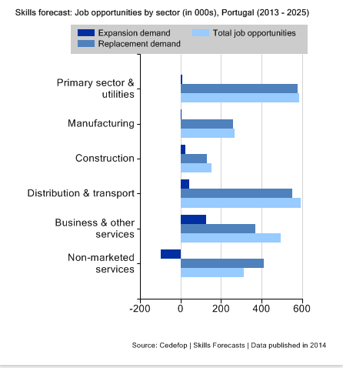

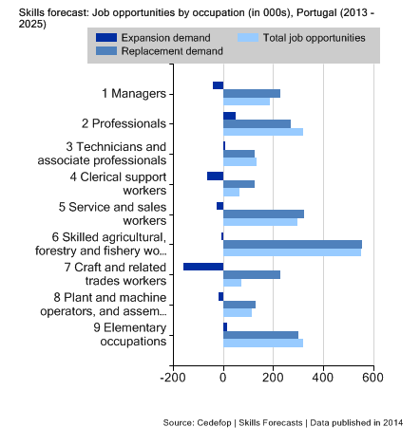
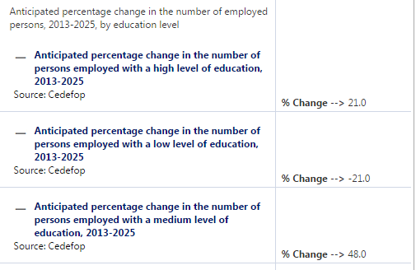
Source: EU Skills Panorama/ CEDEFOP

- VET system in Portugal
The Portuguese education and vocational training system is characterised by a strong centralisation. The Central Government defines the macro political and curricular strategies and guidelines, produces financial guideline, and finances or co-finances the different types of education and vocational training.

The Ministry of Education (ME) and the Ministry of Labour, Solidarity, and Social Security (MTSS) are the major administrators of the education and training system. ME is responsible for pre-primary education, basic education, secondary education, professional courses, school based training and higher education. MTSS is responsible for continuing training, apprenticeship system and the development of active labour market policies. At an operational level the National Agency for Qualifications and Vocational Education and Training (ANQEP) works under the responsibility of ME and MTSS, and the Institute of Employment and Vocational Training (IEFP) operates under the responsibility of MTSS.

The social partners are involved in the general definition of policies for the VET system as they have an advisory role. Within the framework of social dialogue; agreements and commitments have been signed which cover various policy areas including VET. Although social partners have an advisory, their impact on the training and education policies is greater than this implies. Some social partners, such as the employers’ confederations and the trade union confederations, are responsible for delivering training to their members/associates and managing their own Training Centres with the IEFP.

The Portuguese vocational education and training system is based on a set of principles defined under the Basic Law of the Education System (Lei de Bases do Sistema Educativo – LBSE). The legislation was originally passed in 1986 (there have been amendments over the years). It aims to guarantee citizens’ right to access education and training and ensure there is equal access and opportunities to achieve. The most recent amendment led to the setting up of the National Qualifications System, and based on EU and OECD policy recommendations, Portugal increased the duration of compulsory education to cover 12 years from the age of 6 to 18 (Law 85/2009 of 27th August). This amendment makes basic education universal, compulsory and free. There are four sequential and progressive cycles (the 1st cycle lasts four years; the 2nd cycle lasts two years; the 3rd cycle lasts three years and upper secondary education lasts three years) and learners who successful complete their basic education receive a diploma of basic compulsory education and a Level 3 or 4 qualification according to the National Qualifications Framework.

Upper secondary VET education lasts three years and begins at the age of 15. It has different pathways and students can switch between:
- general education – these are courses in sciences and humanities which aim to prepare learners to pursue their studies at a higher education level;
- initial VET – which includes professional courses (cursos profissionais) vocational courses [cursos vocacionais], apprenticeship courses [cursos de aprendizagem], education and training courses for young people [cursos de educação e formação para jovens], specialised art courses [cursos artísticos especializados], adult education and training courses [cursos de educação e formação para adultos]. These initial VET courses qualify students to enter the labour market or continue their studies as the programmes award two certificates - an academic qualification and a professional qualification.

Post-secondary non-tertiary education includes specialised technological courses to prepare and qualify students for work. The courses also give access to higher education, and are divided into units based on credit which can be transferred to the courses in the tertiary education sector. Successful students receive a specialised diploma.

The process of reforming the Portuguese education and training system was restarted in 2007. Despite all the effort to invest in qualifications over the previous two decades, the working population (in general terms) is still poorly qualified and the rates at which young people left school early or dropped out continued to be high. In this context, the reform process has sought to identify innovative solutions in terms of changing objectives, organisational models and the use of resource in order to increase the qualification levels of young people and adults.

The legal framework (Decree-Law 396/2007 of 31st December) establishes the basis for the National Qualifications System (SNQ) and defined its structure. The SNQ defines the different ways that learners can obtain a qualification through training which is covered by the National Qualifications Catalogue (CNQ) and the processes for the recognition, validation and certification of skills (RVCC).

The SNQ is also supported by the National Qualifications Framework (QNQ) which defines national qualification levels according to the European Qualifications Framework (EQF) based on learning outcomes. The QNQ includes eight levels of qualification.

The National Qualifications Catalogue is a central instrument for the strategic management of professional qualifications and regulates the training which leads to the double certification process – school/academic and professional – and promotes the efficient use of public finance. For each qualification the CNQ publishes a vocational profile, training reference and the Skills Recognition, Improvement and Certification (RVCC) reference. Currently, the CNQ looks after 285 qualifications which are organised into 39 areas of education and training and include 128 RVCC references.

There are 16 Sector Councils with responsibility for qualifications. These were created to respond to the needs of industry. They are technical groups which include representatives from Ministries which are responsible for each sector, social partners, enterprises, representatives of VET providers (e.g. state schools, IEFP training centres, certified VET providers), and regulating authorities. They:
- work with experts to update the National Qualifications;
- identify the changes taking place in each sector of the economy and evaluate the impact these changes have on qualifications;
- update the CNQ;
- they help to build and maintain collaborative networks.

In Portugal VET funding is almost entirely provided by public funding from the State budget, the Social Security Budget and the European Social Fund (ESF).

In an attempt to understand the complex relationship between VET and the financial return for individuals and society at large, leading organisations like the OECD have examined the returns on VET investment. In terms of the public monetary costs and the public monetary benefits of the Portuguese VET system over an individual's working life, the OECD (2012b) demonstrates that public returns of upper secondary or post-secondary non-tertiary education are positive, and are nearly twice as large as the overall public costs. And the public returns from tertiary education are much higher, partly because individuals bear some of their own costs of education at university level.

Although some types of initial VET have been in place for years (e.g. apprenticeship pathway) recent changes have helped to modernise the system and give it more internal coherence. The key principles that underlie VET provision are shown below:

Initial VET: key principles
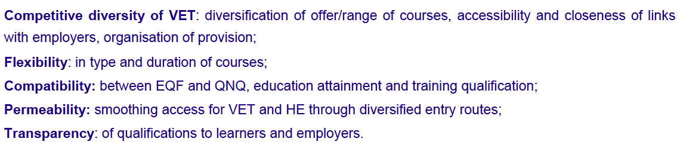
Portugal VET in Europe – Country report-REFERNET, 2012

A special mention should be made to the permeability offered by the double certification process. This mechanism is an important instrument which promotes parity of esteem between general education and VET; it opens new pathways to learners in relation to education and training and it helps to make VET more attractive.

3) Apprenticeship training

3.1 Definition of apprenticeship
Apprenticeship courses were launched in Portugal in 1984. These were one of the initial VET pathways for young people and they were based on an alternance training model with privileged entry to the labour market and opportunities to progress to higher education. Each course uses the double certification model and confers a NQF level 4 vocational qualification and an upper secondary academic qualification. The apprenticeship involves alternating periods (up to three years) in a training centre and at the workplace.

The apprentice has a training contract with the training provider. For the work based period this contract is extended to the company in a tripartite relationship. The courses are for young people who must meet the following age limits and school qualifications:
- aged between 15 and 25;
- have completed the 3rd cycle of basic education (lower secondary level); or
- have a qualification above 3rd cycle of basic education (lower secondary level) without having completed upper secondary education or equivalent.

The courses are under the responsibility of MTSS and they are regulated and quality assured by the IEFP. As these organisations are part of the national public employment service, they aim to promote employment and reduce unemployment by developing policies which support vocational training and apprenticeship. The IEFP has 53 vocational training centres of which 23 are co-managed by IEFP and social partners.

Data from the Employment and Training Measures Evaluation System (Sistema de Avaliação das Medidas de Emprego e Formação) observe that those participating in apprenticeship courses (compare to other employment and training measures) have relatively high rates of employment especially in the case of male students. However apprenticeship courses mean that participants/learners take longer to get employed as the courses are longer than other forms of training. During the course (up to three years) students do not look for a job and they are absent from the labour market.

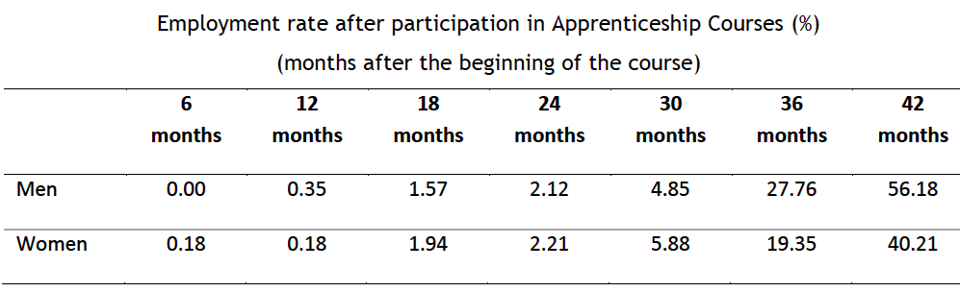

More than 50% of those who complete an apprenticeship course either enter the labour market or continue their education.

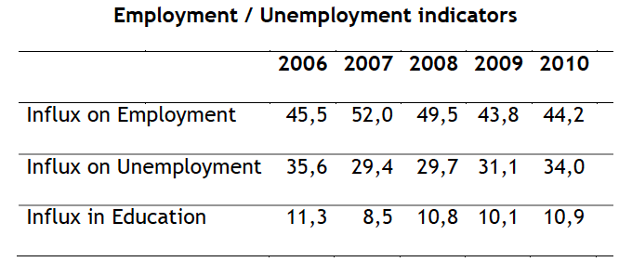

3.2 Legislative framework

Ordinance no. 1497/2008 updated the apprenticeship study plans; regulates the conditions which give access to apprenticeships; re-organised the management of the courses; reviewed the arrangements for evaluation; and the processes for certificating the learning outcomes. Although is a school base system there is the aim to include social skills to a better employability.

Training alternates between the training provider - where the social, cultural, scientific and technological training is based - and the alternating supporting organisation where practical and work-based training takes place.

Main components of an apprenticeship

Components | Objectives
Social/cultural  training | Interdisciplinary and transversal training which helps learners to acquire or strengthen academic, personal, social and professional skills. It includes training on integration in a working environment and adapting to different working contexts (e.g. the development of Portuguese and foreign language skills).
Scientific training | This component is based on the acquisition of skills associated with science, the underpinning technologies, and transdisciplinary and transversal logic as applied to the learning needs of a particular occupation (e.g. mathematics).
Technological training | This component is integrated with other components of training and develops trainees’ technological skills in order that they can develop practical skills and solve problems facing a particular profession (e.g. industrial CAD, CNC milling etc.).
Work - based learning | This component aims to develop new skills and consolidate those acquired during training. It is based on professionally relevant activities which help to facilitate learners’ future employability.

VET providers and companies cooperate on apprenticeship courses. Those VET providers who offer apprenticeships are the ones with good links with companies as these courses are the only ones have the compulsory alternance training model. In these three year courses 60% of the time is spent in a training centre and 40% of the time is in a company.

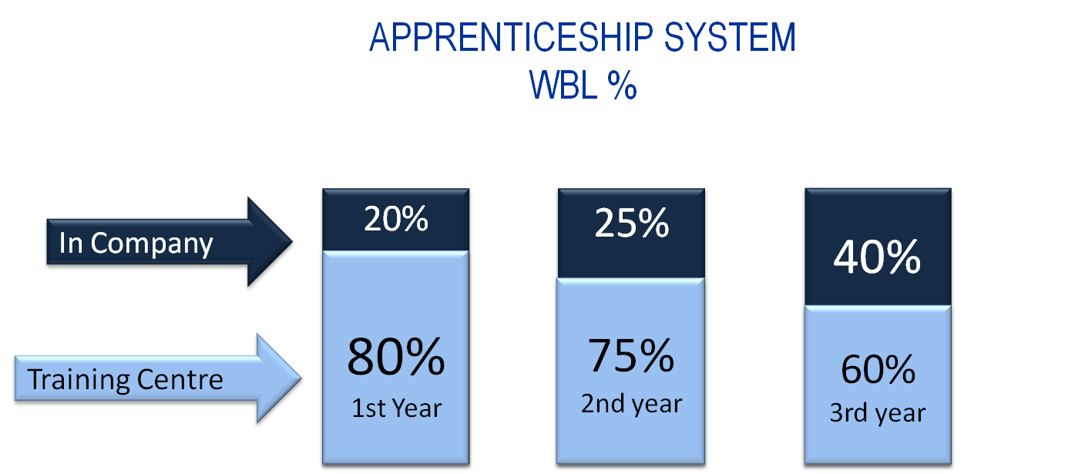
Questionnaire to BUSINESSEUROPE members CIP; Portugal

Enterprises do not receive any financial support for the apprentice, and trainees receive no additional funding during their time in the company.

3.3 Some work based learning programmes

The Ministry of Education has just started (three years ago) a new pathway - Vocational Courses – which offers work based learning in schools. It has been designed for 16 year olds with lower-secondary education or for those who have attended secondary education but are looking for a more technical pathway or who are at risk of dropping out. Prior to their enrolment in this pathway they receive career guidance.

There is also a professional course (another pathway under the control of the Ministry of Education) which was created in 1989 for young people between the ages of 15 and 20 who have completed lower-secondary education and want to develop the personal and professional skills required for entering the labour market or undertaking further study. In both of these pathways work - based learning is only required at the end of the second or third years of the course.

Training component | Apprenticeship courses |  | Vocational courses |  | Professional courses
 | Number of hours | % | Number of hours | % | Number of hours | %
 | Level 4  (3 years) |  | Level 4  (2 years) |  | Level 4  (3 years)
Socio-cultural  Training | 800 | 22% | 600 | 20% | 1000 | 29%
Scientific training | 400 | 11% | 300 | 10% | 500 | 15%
Technological training | 1000 | 27% | 700 | 23% | 1.100 | 32%
Work - based learning | 1500 | 41% | 1400 | 47% | 840 | 24%
TOTAL hours | 3700 | 100% | 3000 | 100% | 3440 | 100%
Own elaboration

3.4 Number of students
The percentage of Portuguese students in general education exceeds the percentage in vocational education but this proportion has decreased over the last ten years (it was above 50% in 2010). According to data provided by Ministry of Education (DGEEC), 42.8% of students in secondary education (EQF Level 3 and 4) were enrolled in the VET system in 2012.

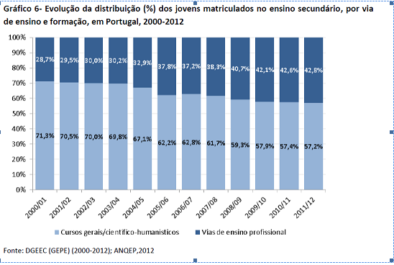

For students in the VET system about 13% were enrolled in the apprenticeship system.

Students enrolled in secondary education in terms of education / training by type
Anos
 | Total | Regular education | Apprenticeship | Professional | Others
2007 | 356.711 | 196.149 | 16.716 | 47.709 | 63.097
2008 | 349.477 | 196.337 | 14.125 | 70.177 | 47.177
2009 | 498.327 | 195.688 | 13.584 | 93.438 | 169.190
2010 | 483.982 | 197.711 | 17.619 | 107.266 | 142.523
2011 | 440.895 | 198.085 | 18.669 | 110.462 | 96.274
2012 | 411.238 | 199.321 | 21.056 | 113.749 | 62.804
2013 | 398.447 | 201.336 | 33.366 | 115.885 | 36.615
2014 | 385.210 | 201.118 | 35.400 | 117.699 | 22.344
DGEEC/MEC, PORDATA update 2015-07-16

In 2014, 35,400 trainees were enrolled on an apprenticeship: the numbers have grown from year to year. The sector with the most students is the metal sector.

3.5 Contractual arrangements

An apprenticeship has a training contract with the training organisation. This sets out the rights and duties of both parties based on the relevant legislation. This contract includes the following: objectives of the contract; the location of the training; the training schedule, assessment and certification criteria; the rights and duties of the trainee; the rights and duties of the training organisation and the organisation providing support to alternance; the duration of the agreement; contract cessation; sanctions; regulations; funding; applicable legislation. This contract does not establish a working relationship and it ends when the trainee completes the course or training. A tutor is appointed by the organisation responsible for the practical component of the workplace training.

The trainees’ assessment is continuous, and it is supported by a systematic evaluation of the activities completed by the trainee during their work placement. The trainee’s results are formalised in the middle and at the end of the training period through an assessment. Throughout the practical workplace training there is technical and pedagogical support from a work-based tutor at the organisation which provides the placement. This tutor collaborates with the training provider. An apprenticeship is completed after the trainee takes the Final Evaluation Exam which assesses their vocational performance through the completion of one or more practical works as defined in the occupational profile.

3.6 Bilateral cooperation
Portugal is one of the countries working closely with Germany to reform their systems of vocational training and education. The Minister of Education Portugal and the Minister for Education and Research of Germany signed a memorandum for Education and Research in December 2012. It includes concrete measures for introducing a vocational education system based on Germany’s model. The agreement will help to meet the EU’s goal of having 80 per cent of all young people in the EU employed by 2020. Across Europe nearly one in four adults under the age of 25 are without work. At 7 per cent, Germany’s youth unemployment rate is the lowest among EU countries – this is attributed to the Dual system of education and training which is closely linked to industry and the job market.

In this context the two governments agreed to develop a comparative analysis of their respective systems and structures of VET. This includes:
- details on the curricula; access requirements; involvement and role of business; requirements for trainers and sharing of best practices;
- exchanging information on practices in guidance services;
- opportunity for peer learning.
The governments also agreed to promote the exchange of VET students, educational professionals and business representatives. A training programme for work-based learning tutors in companies has been developed as part of this collaboration. A working group with representatives from both countries has been established to co-ordinate, monitor and evaluate the implementation of the Memorandum of Understanding.

German social partners are supporting the initiative. Leading organisations in trade and industry are preparing and finalising contracts to transfer German principles of training to partner organisations in other countries. The German Chamber of Commerce and German businesses with locations in partner countries will play a central role, particularly in the regional development of vocational training networks with businesses, schools and chambers in the country.

One example of this cooperation is ATEC (Associação de Formação para a Indústria) which is a non-profit training association established in 2003 by Volkswagen Autoeuropa, Siemens, Bosch and the Portuguese-German Chamber of Commerce and Industry. ATEC is responsible for developing and promoting courses which are tailored to the needs of companies, such as, specialised IT courses, energy management, mechatronics, robotics, automation and industrial maintenance and metalworking. ATEC provides advanced and up-to-date technical and technological education with improves learners’ employability. The trainees are prepared for the real work by adhering to the rules of conduct at the workplace and by following working hours defined by the labour regulations and not by the school calendar. ATEC organises an annual job fair and open day where students, teachers, vocational trainers and families are invited to learn more about the courses.

4) Drop-out rates from school and apprenticeships and alternative pathways for young people

In Portugal the drop-out rate for those aged 18-24 years old is very high compared to the average in the EU28. In 2007 Portugal recorded a drop-out rate of 36.5% (the EU28 rate was 14.9%), in 2012 it was 20.5% (the EU28 rate was 12.7%) and in 2014 it was 17.7% (the EU28 rate was 11.3%). A remarkable effort has been made to bring this number down to 18% in 2014. Among other measures which have supported this reduction, the increase of VET provision supported by European Social Funds has played a key role in improving students’ performance and reducing dropout rates (QREN, 2009; QREN, 2010). There are significant gender differences in early school leavers: 24% of boys and 14.5% of girls dropped out of school in 2013. Despite significant improvements in recent years a high dropout rates remains a challenge in Portugal’s education system as leaving school early has a major impact on young people’s life chances.

5) Future reforms in the apprenticeship system

The government is seeking to ensure the quality, attractiveness and labour market relevance of VET through partnerships with companies or other stakeholders, and by enhancing the career guidance offered to prospective students. Over the past two decades, Portugal’s VET system has expanded its scope to encompass a wide range of higher skilled occupations such as renewable energies, electronics and automation, ICT, aeronautics, and accounting and business administration. In the area of tourism – an important and growing part of the Portuguese economy – there is a strong demand for VET from young people and a training offer has been developed in recent years at both the upper-secondary and post-secondary level. A new methodology for designing and describing qualifications based on learning outcomes has been implemented since 2014 with some success in Tourism and Commerce sectors. In addition a number of VET pathways are now available at lower secondary and upper secondary levels for young people aged from 15 to 24.

Since 2007, as part of the National System for Qualifications, VET reform has concentrated on the learning outcomes dimension of developing qualifications standards and the curriculum. The qualifications in each VET sub-system are organised using standards which are included in the national qualifications catalogue. Each qualification is organised in terms of units. There is on-going work to adjust qualifications so they match the level descriptors (about 25% of the qualifications have been updated and their learning outcomes have been adjusted to the level descriptors).

VET stakeholders continue their work to remove the negative image surrounding the system and to present VET as a pathway that leads to quality employment opportunities. VET is being presented to students and their parents as a real option and not a "second choice". These initiatives start with effective communication about the VET system in schools. However good quality information about VET is needed across the education system - especially in public schools which focus on preparing students for higher education. Providing better information about the wide-range of VET options for students would not only improve the match between student interests and courses, but also contribute to reducing school dropout rates.

Recent reforms have helped to reinforce the value of apprenticeships and increase the supply of apprenticeships managed by the Employment and Vocational Training Institute (IEFP).

In 2015 to take action on the mismatch between skills demanded by employers and those provided through training, the System for the Diagnosis of Qualifications Needs (SANQ) was established. This system highlights the skills which are needed, and the growing professions and work activities. It produces clear guidelines to define the training offer and to update the National Qualifications Catalogue. Currently those operators that are co-financed by ESF are required to have their training offer aligned with the priorities defined in SANQ.

In relation to the European Alliance for Apprenticeships, the Portuguese government have not submitted concrete commitments to increase the quantity, quality and supply of apprenticeships.

6) Evaluation of the existing system and potential ways to improve it

Portugal does not have Chambers of Skilled Crafts or Commerce. However the Employers’ Associations and Confederations assume a role which focuses on disseminating and supporting the VET system. According to the CIP - Confederação Empresarial de Portugal - to improve the attractiveness of apprenticeships it is necessary to overcome the historically connection with ‘blue collar’ employment which is seen as a disadvantage to a young person. A number of measures are required to build a better image of the apprenticeship:
- increased visibility to the apprenticeship system with marketing campaigns addressing school guidance systems, teachers, companies and the community;
- training the trainers in relation to new pedagogical approaches in the VET system. This should include pedagogy for the apprenticeship system in order to help teachers move from their traditional approach to one which supports VET training. To succeed there will be a need for peer learning activities and study visits;
- companies need to be better motivated to become involved in the VET system. The associations need to provide advice, promote cooperation between companies, encourage the exchange of best practice and ensure the funding of transversal training activities of employers’ organisations at the national, sector or regional level;
- promote greater synergy between different operators through protocols to allow the general education schools to provide the social and cultural training while the training centres provide the technological training and the companies provide work-based learning;
- to increase VET provision there is a need to rationalise the investments in equipment through better planning between schools and training centres at regional level. Sometimes there are incomprehensible overlaps;
- strengthen the incentives for enterprise to develop and train their tutors;
- increase the involvement of enterprises in VET forums to ensure that the key competences needed by employers are integrated into the curricula.

CIP comments that apprenticeships should be developed up to EQF Level 6 as a way to offer integrated curricula, not just as a way to increase the attractiveness of apprenticeships. This would also help to reduce the mismatch between the higher education courses and the needs of the labour market.
In order to engage more SMEs in apprenticeships it is necessary deliver better information about the system, better information about the advantage of work-based learning, and better information about how training benefits the quality of the employers’ outputs.

7) Cost effectiveness analysis

It’s important to remember that in Portugal companies have no direct costs associated with enrolling a trainee in the Apprenticeship System. The indirect costs to the company are mainly related to the tutor’s time. The benefits for the company are related to the development of a skilled workforce. In this context, CIP highlight that there is a lack of co-funded support for companies i.e. there is no funding to cover the cost of providing practical training in the workplace (raw material, wear of equipment, supplies) or to compensate the company for the deployment of tutors who train apprentices.

The average length of time necessary for a former apprentice to get a job varies according to the sector and there is no consistent information available. However information from annual monitoring by CENFIM - Vocational Training Centre of the Metal Industry (www.cenfim.pt), in partnership between IEFP and the Metal Associations affiliated to CIP, it is possible to see the following:

Integration into working life in the metal industry
Courses completed in 2012

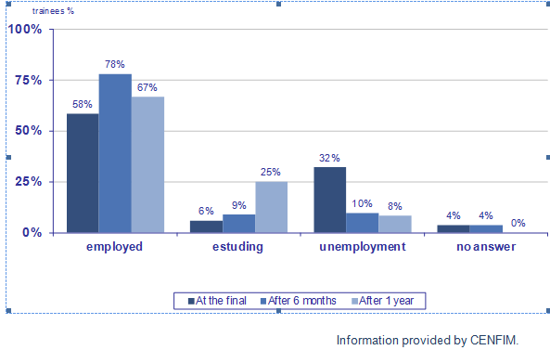

The data shows that about 60% of those leaving training get a job immediately and about 80% get a job within six months of completing their course. The data also shows that trainees’ contribution to the employers’ production grows in line with the skills they acquire during their course i.e. they are able to make a smaller contribution in the first year and a greater contribution during their third year of training. After completing the three years of their courses (including the work-based learning) the new professional normally needs one year to be completely integrated into the workplace.

Revised on February 2016 after cluster seminar

Eurostat - Dec.2014
Reintegração da população NEET no mercado de trabalho e no sistema de educação e formação (R-NEET); SERGA
NEETs Young people not in employment, education or training: Characteristics, costs and policy responses in Europe, EUROFOUND,2012
Instituto Nacional de Estatística
EUROSTAT Database/LFS
Skills forecasts - main results-CEDEFOP
Questionnaire to BUSINESSEUROPE members CIP; Portugal
Portugal VET in Europe – Country report-REFERNET, 2014
The European Commission defines apprenticeships as formally combining and alternating company-based training (periods of practical work experience at a workplace) with school-based education (periods of theoretical/practical education followed in a school or training centre), and lead to nationally recognised qualification upon successful completion. Most often there is a contractual relationship between the employer and the apprentice, with the apprentice being paid for his/her work. European Commission “European Alliance for Apprenticeships - Good for Youth, Good for Business”.
Monica COSTA DIAS e José VAREJO Junho 2012 - FEP Faculdade de Economia Universidade do Porto
Apprenticeship-type schemes and structured work-based learning programmes, Portugal-Refernet, CEDEFOP,2014
Portugal Vet in Europe - Country Report - Refernet 2012
16.716 IEFP figures
14.125 IEFP figures
Apprenticeship and Traineeship Schemes in EU27: Key Success Factors, A Guidebook for Policy Planners and Practitioners December 2013,EC
German Federal Ministry of Education and Research
The others are: Spain, Latvia, Greece, Italy and Slovakia.
OECD Skills Strategy Diagnostic Report Portugal 2015
EUROSTAT,Database/LFS
OECD Skills Strategy Diagnostic Report Portugal 2015
Portugal VET in Europe – Country report-REFERNET,2012,
PORTUGAL European inventory on NQF 2014
OECD Skills Strategy Diagnostic Report Portugal 2015,page 41
Ministry of Economy, Portugal (2013), Industrial development strategy for growth and jobs 2014-2020
http://sanq.anqep.gov.pt
Questionnaire to BUSINESSEUROPE members CIP- Confederação Empresarial de Portugal

